

|  |  |
| --- | --- |
|  | **MINISTRY OF EDUCATION AND TRAINING** |

**Capstone Project Report**

**Report 4 – Software Design Document**

– Ho Chi Minh, September 2024 –

**I. Record of Changes 6**

**II. Software Design Document 7**

1. System Design 7

1.1. System Architecture 7

1.1.1. Overall System Architecture (TBD) 8

1.2. Package Diagram 8

1.2.1. Web Application Package Diagram 8

1.2.2. Mobile Application Package Diagram 10

1.2.3. Backend Application Package Diagram 12

2. Database Design 13

2.1. Database 14

2.2. Data Dictionary 14

2.2.1. Academic counselor Table 14

2.2.2. Account table 14

2.2.3. Appointment feedback Table 15

2.2.4. Appointment_for_demand table 15

2.2.5. Appointment_report table 16

2.2.6. Available_date_range table 17

2.2.7. Chat_session table 17

2.2.8. Counseling_appointment table 18

2.2.9. Counseling_appointment_request 19

2.2.10. Counseling_demand Table 20

2.2.11. Counseling_slot table 21

2.2.12. Counselor table 22

2.2.13. Counselor_slot table 22

2.2.14. Demand_problem_tag table 22

2.2.15. Department table 23

2.2.16. Expertise table 23

2.2.17. Holiday table 24

2.2.18. Login_type table 24

2.2.19. Major table 25

2.2.20. Message table 25

2.2.21. Non_academic_counselor table 26

2.2.22. Notification table 26

2.2.23. Offline_appointment table 27

2.2.24. Online_appointment table 27

2.2.25. Problem_category table 27

2.2.26. Problem_tag table 28

2.2.27. Profile table 28

2.2.28. Question_ban table 29

2.2.29. Question_card table 29

2.2.30. Question_flag table 31

2.2.31. Semester table 31

2.2.32. Specialization table 32

2.2.33. Student table 32

2.2.34. Student_counseling_profile table 33

2.2.35. Support_staff table 34

2.2.36. Topic table 34

2.2.37. Certifications table 35

2.2.38. Contributed_question_card_category table 35

2.2.39. contribution_question_card table 35

2.2.40. qualifications table 36

3. Detailed Design 36

3.1 Booking, handling, and tracking counseling appointments: 36

3.1.1. Class Diagram 36

3.1.1.1. Class Specification 37

3.1.1.1.1. CounselorController class 37

3.1.1.1.2. CounselorService class 37

3.1.1.1.3. CounselorServiceImpl class 38

3.1.1.1.4. NotificationServiceImpl class 38

3.1.1.1.5. CounselingAppointmentRequestServiceImpl class 39

3.1.1.1.6. BookingCounselingController class 39

3.1.1.1.7. CounselorRepository class 40

3.1.1.1.8. CounselingAppointmentRequestService class 40

3.1.1.1.9 . OpenAIServiceImpl class 40

3.1.1.1.10 . OpenAIServiceImpl class 41

3.1.1.1.11. NotificationService class 41

3.1.1.1.12 . OpenAIService class 42

3.1.1.1.13 . NotificationRepository class 42

3.1.1.1.14 . Notification class 43

3.1.1.1.15 . CounselingAppointmentService class 43

3.1.1.1.16 . CounselingAppointmentServiceImpl class 43

3.1.1.1.17 . AppointmentFeedback class 44

3.1.1.1.18 . AppointmentFeedbackRepository class 44

3.1.1.1.19 . AppointmentReportRepository class 44

3.1.1.1.20 . AppointmentReport class 44

3.1.1.1.21 . CounselingAppointmentRequestRepository class 45

3.1.1.1.22 . Counselor class 45

3.1.1.1.23 . CounselingAppointmentRequest class 46

3.1.1.1.24 . CounselingAppointment class 46

3.1.1.1.25 . AppointmentForDemand class 46

3.1.1.1.26 . StudentRepository class 46

3.1.1.1.27. CounselingDemandRepository class 47

3.1.1.1.28. CounselingAppointmentRepository class 47

3.1.1.1.29 . Student class 47

3.1.1.1.30 . CounselingDemand class 47

3.1.2. Sequence Diagram 49

3.1.2.1. Sequence Diagram 49

3.1.2.1.1. Student quick matching counselor 49

3.1.2.1.2. Student creates appointment request 50

3.1.2.1.3. Counselor Approves appointment request 51

3.1.2.1.4. Take attendance 51

3.1.2.1.5. Student provide feedback 52

3.1.2.1.6. Counselor cancel appointment 52

3.1.2.1.7. Student cancel appointment 53

3.1.3. Activity Diagram 53

3.1.3.1. Create Booking request with quick booking 53

3.1.3.2. Create booking request with choosing a specific counselor 55

3.1.3.3. Take attendance 55

3.1.3.4. Provide Feedback 56

3.1.3.5. Cancel Appointment 57

3.1.4. State Machine Diagram 60

3.1.4.1. Booking Appointment State Machine Diagram 60

3.2. Student Questions and Counselor Support 60

3.2.1. Class Diagram 61

3.2.1.1. Class Specification 61

3.2.1.1.1. Counselor class 61

3.2.1.1.2 . StudentRepository class 62

3.2.1.1.3. CounselorRepository class 62

3.2.1.1.4. Student class 62

3.2.1.1.5. QuestionCard class 63

3.2.1.1.6. QuestionBan class 63

3.2.1.1.7. NotificationService class 63

3.2.1.1.8. NotificationServiceImpl class 64

3.2.1.1.9 . NotificationRepository class 64

3.2.1.1.10. Notification class 64

3.2.1.1.11. ChatSession class 64

3.2.1.1.12. Message class 65

3.2.1.1.13. MessageRepository class 65

3.2.1.1.14. MessageRepository class 65

3.2.1.1.15. QuestionFlag class 65

3.2.1.1.16. QuestionFlagRepository class 65

3.2.1.1.17. QuestionBanRepository class 65

3.2.1.1.18. QuestionCardServiceImpl class 65

3.2.1.1.19. QuestionCardController class 67

3.2.1.1.20. QuestionCardController class 68

3.2.1.1.21. OpenAIService class 68

3.2.1.1.22. QuestionCardRepository class 69

3.2.1.1.23. OpenAIService class 69

3.2.1.1.24. NonAcademicCounselor class 70

3.2.1.1.25. AcademicCounselor class 70

3.2.1.1.26. ExpertiseRepository class 70

3.2.1.1.27. AcademicCounselorRepository class 70

3.2.1.1.28. NonAcademicCounselorRepository class 71

3.2.1.1.29. Expertise class 71

3.2.2. Sequence Diagram 71

3.2.2.1. Student creates question card 71

3.2.2.2. Counselor answers question sequence diagram 72

3.2.2.3. Counselor closes question sequence diagram 72

3.2.2.4. Student accepts question sequence diagram 73

3.2.2.5 Student initiates chat sequence diagram 73

3.2.3. Activity Diagram 74

3.2.3.1. Create question 74

3.2.3.2. Accept question 74

3.2.3.3. Answer question 76

3.2.3.4. Flag question 77

3.2.3.5. Close question 78

3.2.3.6. Chat in session 79

3.2.4. State Machine Diagram 79

3.2.4.1. Q&A State Machine Diagram 80

3.3. Staff-Driven Student Support and Counselor Matching for student’s demand 80

3.3.1. Class Diagram 80

3.3.1.1. Class Specification 80

3.3.1.1.1. CounselorController class 80

3.3.1.1.2. CounselorService class 81

3.3.1.1.3. CounselorServiceImpl class 81

3.3.1.1.4. CounselorRepository class 82

3.3.1.1.5. Counselor class 82

3.3.1.1.6. Student class 83

3.3.1.1.7. CounselingDemand class 83

3.3.1.1.8. StudentFollowing class 84

3.3.1.1.9. StudentRepository class 84

3.3.1.1.10. SupportStaffRepository class 84

3.3.1.1.11. CounselingDemandController class 84

3.3.1.1.12. CounselingDemandRepository class 84

3.3.1.1.13. SupportStaff class 85

3.3.1.1.14. CounselingDemandService class 85

3.3.1.1.15. CounselingDemandService class 85

3.3.1.1.16. CounselingDemandServiceImpl class 85

3.3.1.1.17. CounselingDemandService class 86

3.3.1.1.18. StudentServiceImpl class 86

3.3.2. Sequence Diagram 87

3.3.2.1. Support staff follows student 87

3.3.2.2. Support staff create demand card 88

3.3.2.3. Counselor creates appointment and attach to demand card 89

3.3.2.4. Counselor solves demand card 90

3.3.3. Activity Diagram 91

3.3.3.1. Staff Create demand card for mapping counselor with student 91

3.3.3.1. Counselor Create appointment for demand if student need 92

3.3.3.2. Staff Follow student 93

3.3.3.3. Staff Unfollow student 94

3.3.3.4. Solve demand 95

3.3.4. State Machine Diagram 95

3.3.4.1. Demand Mapping State Machine Diagram 95

# I. Record of Changes

|  |  |  |  |
| --- | --- | --- | --- |
| Date | A*  M, D | In charge | Change Description |
| 23/09/2024 | A | Phạm Tuấn Kiệt | Initialize document |
| 23/09/2024 | A | Lâm Hữu Thuần | Added content:   * System Architecture   User Requirements |
| 24/09/2024 | A | Đỗ Quang Kiệt | Added content:  Package Diagram |
| 25/09/2024 | A | Lâm Hữu Thuần | Added content:  Database Design |
| 26/09/2024 | A | Lý Minh Thông | Added content:  Detail Design |
| 26/09/2024 | M | Phạm Tuấn Kiệt | Modified Detail Design:   * Activity diagram   State Machine diagram |
|  |  |  |  |
|  |  |  |  |
|  |  |  |  |
|  |  |  |  |
|  |  |  |  |
|  |  |  |  |
|  |  |  |  |

*A - Added M - Modified D - Deleted

# II. Software Design Description

## 1. System Design

### 1.1. System Architecture

#### 1.1.1. Overall System Architecture

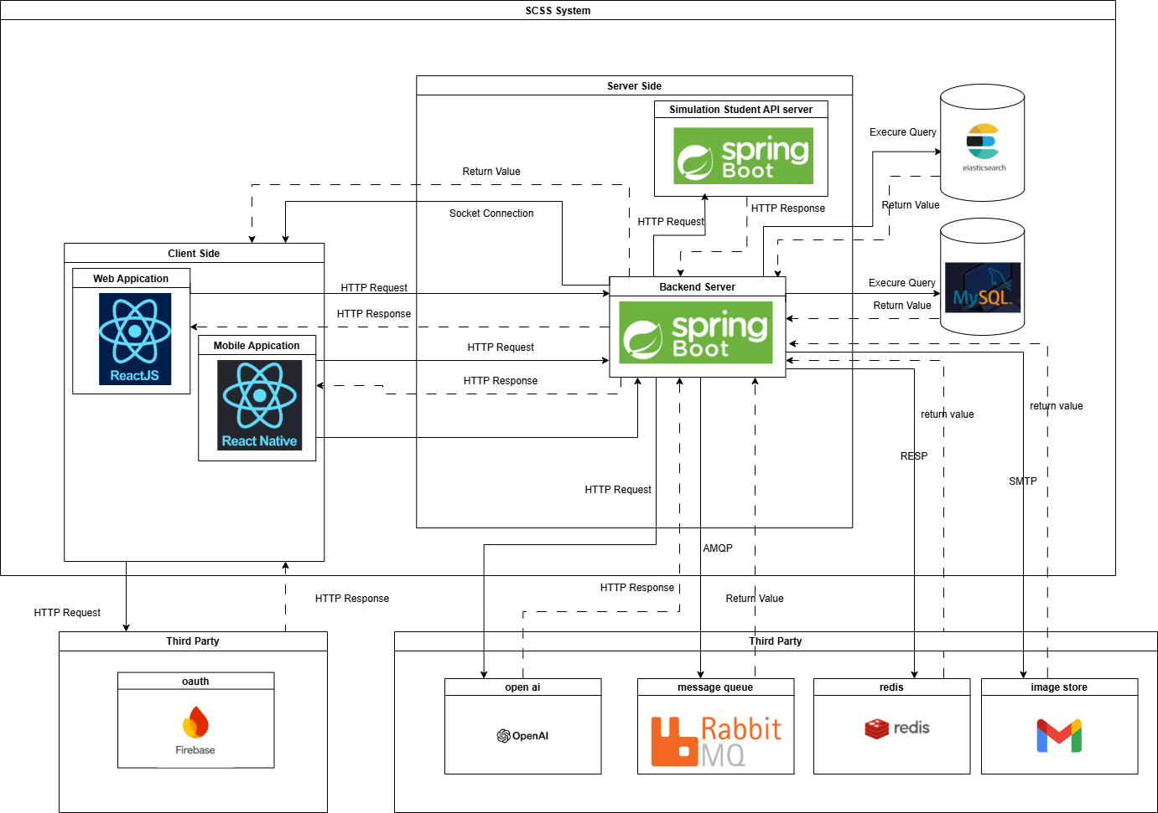

### 1.2. Package Diagram

#### 1.2.1. Web Application Package Diagram

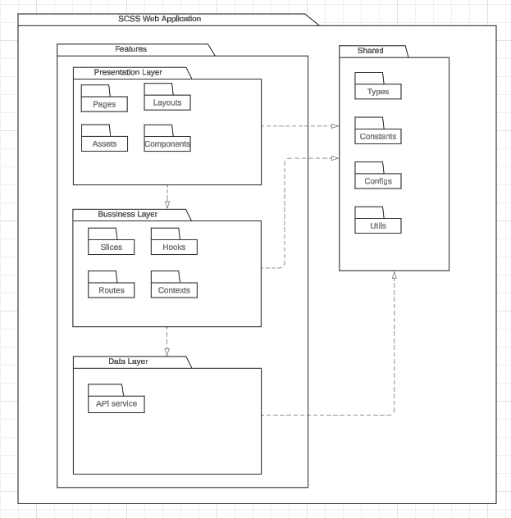

***Package Descriptions***

|  |  |  |
| --- | --- | --- |
| **No** | **Package** | **Description** |
| 01 | Features | This package include all the features of the application |
| 02 | Pages | The package includes page components for the application |
| 03 | Components | This package includes the detailed components of the page interface |
| 04 | Layouts | This package includes the general layouts of the interface |
| 05 | Assets | This package includes static files used by components and pages. |
| 06 | Routes | This package includes a config URL path for routing to the page component. |
| 07 | Slices | This package includes a state management pattern for a web application |
| 08 | Hooks | This  package includes the custom hooks for components used to handle logic. |
| 09 | Constants | This package includes defines constant for the entire application use |
| 10 | API Service | This package includes API service for frontend |
| 11 | Shared | This package includes all common files used by the application |
| 12 | Types | This  package includes common interfaces for the application |
| 13 | Configs | This package includes all common settings for the application. |
| 14 | Context | This packages includes provider the application |

#### 1.2.2. Mobile Application Package Diagram

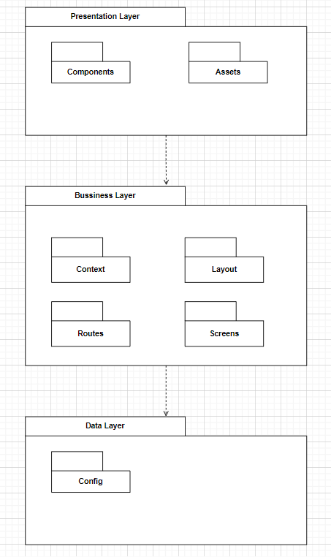

***Package Descriptions***

|  |  |  |
| --- | --- | --- |
| **No** | **Package** | **Description** |
| 01 | Components | It contains the reusable building blocks of the app, which are individual components that manage specific pieces of functionality or UI |
| 02 | Assets | It contains static resources such as images, fonts, and other media files used throughout the app. |
| 03 | Context | It stores context files for managing the global state throughout the application (e.g., user authentication, navigation, notifications). |
| 04 | Layout | It holds layout components responsible for structuring the visual appearance of different sections or screens |
| 05 | Routes | It contains the routing logic for the app, defining how users navigate between different screens or features. |
| 06 | Screens | It contains the major screens of the app. Each screen typically represents a full view or page (e.g., Home, Login, Profile) |
| 07 | Config | It stores configuration files, such as environment settings, API endpoints, and other app-specific constants that might be referenced globally. |

#### 1.2.3. Backend Application Package Diagram

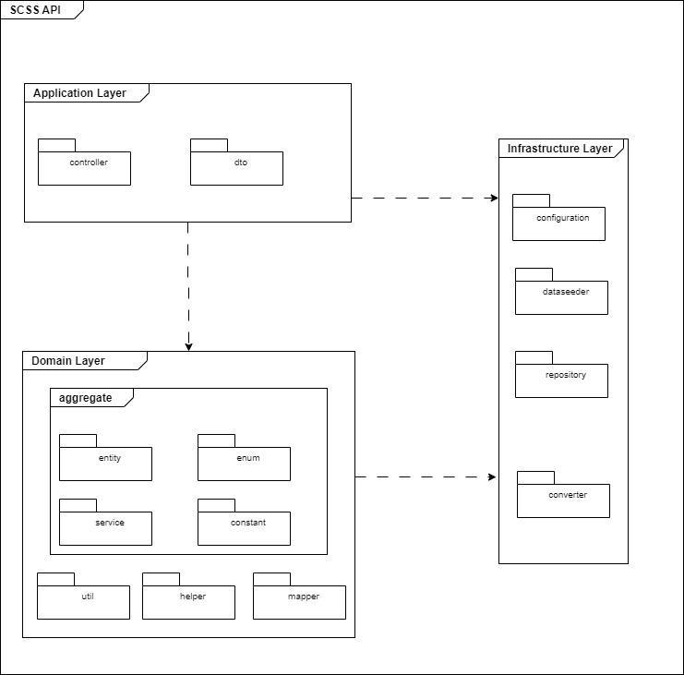

***Package Descriptions***

|  |  |  |
| --- | --- | --- |
| **No** | **Package** | **Description** |
| 01 | Controller | includes the classes that handle HTTP requests and call the relevant domain-layer business logic. They also take care of addressing errors and creating responses. |
| 02 | DTO | contains the classes that act as a bridge between the domain model and the client. They make sure that just the information that is required is visible by encapsulating data delivered to or from the client. |
| 03 | Entity | Defines the business objects and their relationships. |
| 04 | Enum | Contains enumerations that represent fixed sets of constants used across the domain. |
| 05 | Util | Contains utility classes with reusable methods that help the domain logic but do not belong to any specific entity. |
| 06 | Helper | Provides helper functions that facilitate domain-related operations. |
| 07 | Mapper | Manages the mapping between entities and DTOs, ensuring data is converted between different representations. |
| 08 | Configuration | Stores classes related to configuring application settings, such as database connections, security, or other environment-specific setups. |
| 09 | DataSeeder | Holds classes responsible for populating the database with initial or test data. |
| 10 | Repository | Contains interfaces and classes that handle communication with the data storage layer, allowing CRUD operations on domain entities. |
| 11 | Converter | Provides classes for converting data between different types, formats, or structures, such as mapping domain models to persistent data models. |

## 2. Database Design

### 2.1. Database

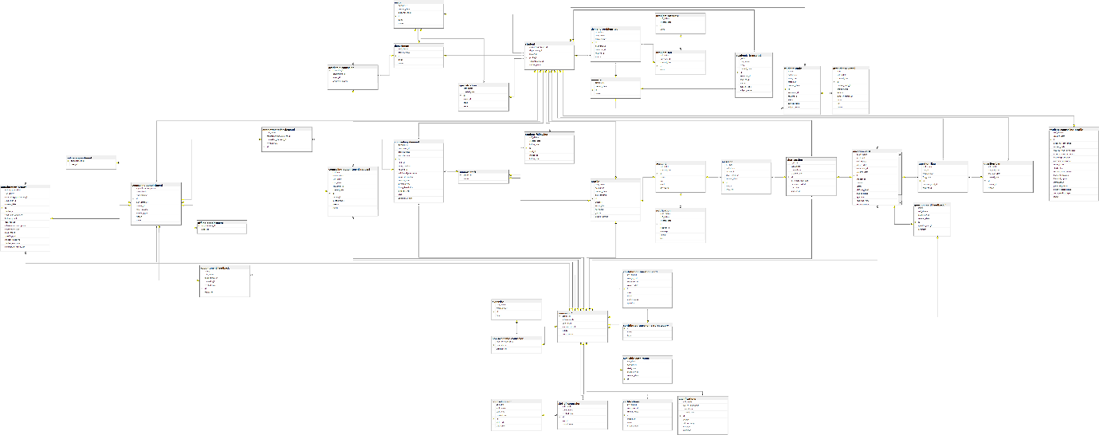

### 2.2. Data Dictionary

#### 2.2.1. Academic counselor table

|  |  |  |  |  |  |  |
| --- | --- | --- | --- | --- | --- | --- |
| **No** | **Field name** | **Type** | **Unique** | **Not null** | **PK/FK** | **Notes** |
| 1 | counselor_id | bigint | X | X | PK |  |
| 2 | department_id | bigint |  | X | FK |  |
| 3 | major_id | bigint |  | X | FK |  |
| 4 | academic_degree | varchar(255) |  | X | FK |  |

#### 2.2.2. Academic_transcript table

|  |  |  |  |  |  |  |
| --- | --- | --- | --- | --- | --- | --- |
| No | Field name | Type | Unique | Not null | PK/FK | Notes |
| 1 | id | BIGINT | X |  | PK |  |
| 2 | grade | DECIMAL(38,2) |  | X |  |  |
| 3 | soft_delete | BIT(1) |  | X |  |  |
| 4 | term | INT |  | X |  |  |
| 5 | created_date | DATETIME(6) |  | X |  |  |
| 6 | semester_id | BIGINT |  |  |  |  |
| 7 | student_id | BIGINT |  | X |  |  |
| 8 | subject_code | VARCHAR(255) |  | X |  |  |
| 9 | subject_name | VARCHAR(255) |  | X |  |  |
| 10 | status | enum |  |  |  | Has value:   * NOT_PASSED * NOT_STARTED * PASSED * STUDYING |

#### 2.2.2. Account table

|  |  |  |  |  |  |  |
| --- | --- | --- | --- | --- | --- | --- |
| **No** | **Field name** | **Type** | **Unique** | **Not null** | **PK/FK** | **Notes** |
| 1 | id | bigint | X | X | PK |  |
| 2 | soft_delete | bigint |  | X |  |  |
| 3 | created_date | bigint |  | X |  |  |
| 4 | status | varchar(20) |  | X |  |  |
| 5 | role | varchar(50) |  | X |  |  |
| 6 | email | varchar(255) | X |  |  |  |
| 7 | password | varchar(255) |  |  |  |  |

#### 2.2.3. Appointment feedback Table

|  |  |  |  |  |  |  |
| --- | --- | --- | --- | --- | --- | --- |
| **No** | **Field name** | **Type** | **Unique** | **Not null** | **PK/FK** | **Notes** |
| 1 | id | bigint | X | X | PK |  |
| 2 | rating | decimal(38,2) |  | X |  |  |
| 3 | soft_delete | bit(1) |  | X |  |  |
| 4 | appointment_id | bigint | X | X | FK |  |
| 5 | created_date | varchar(255) |  | X |  |  |
| 6 | comment | varchar(255) |  |  |  |  |
| 7 | counselor_id | bigint | X | X | FK |  |

#### 2.2.4. Appointment_for_demand table

|  |  |  |  |  |  |  |
| --- | --- | --- | --- | --- | --- | --- |
| **No** | **Field name** | **Type** | **Unique** | **Not null** | **PK/FK** | **Notes** |
| 1 | id | bigint | X | X | PK |  |
| 2 | soft_delete | bit(1) |  | X |  |  |
| 3 | counseling_appointment_id | bigint | X | X | FK |  |
| 4 | created_date | bigint |  | X |  |  |
| 5 | counseling_demand_id | bigint |  | X | FK |  |

#### 2.2.5. Appointment_report  table

|  |  |  |  |  |  |  |
| --- | --- | --- | --- | --- | --- | --- |
| **No** | **Field name** | **Type** | **Unique** | **Not null** | **PK/FK** | **Notes** |
| 1 | id | bigint | X | X | PK |  |
| 2 | follow_up_needed | bit(1) |  |  |  |  |
| 3 | soft_delete | bit(1) |  |  |  |  |
| 4 | counseling_appointment_id | bigint | X | X | FK |  |
| 5 | counselor_id | bigint | X | X | FK |  |
| 6 | created_date | bigint |  | X |  |  |
| 7 | student_id | bigint | X | X | FK |  |
| 8 | counselor_conclusion | text |  |  |  |  |
| 9 | follow_up_notes | text |  |  |  |  |
| 10 | goal_reason | text |  |  |  |  |
| 11 | intervention_description | varchar(255) |  | X |  |  |
| 12 | intervention_type | varchar(255) |  | X |  |  |
| 13 | main_issues | text |  |  |  |  |
| 14 | specific_goal | text |  |  |  |  |
| 15 | student_emotions | text |  |  |  |  |
| 16 | student_reactions | text |  |  |  |  |
| 17 | summary_of_discussion | text |  |  |  |  |

#### 2.2.6. attendance_detail table

|  |  |  |  |  |  |  |
| --- | --- | --- | --- | --- | --- | --- |
| **No** | **Field name** | **Type** | **Unique** | **Not null** | **PK/FK** | **Notes** |
| 1 | id | BIGINT |  | X | PK |  |
| 2 | date | DATE |  | X |  |  |
| 3 | soft_delete | BIT(1) |  | X |  |  |
| 4 | created_date | DATETIME(6) |  | X |  |  |
| 5 | student_study_id | BIGINT |  | X | FK |  |
| 6 | group_name | VARCHAR(255) |  | X |  |  |
| 7 | lecturer | VARCHAR(255) |  | X |  |  |
| 8 | lecturer_comment | VARCHAR(255) |  |  |  |  |
| 9 | room | VARCHAR(255) |  | X |  |  |
| 10 | slot | VARCHAR(255) |  | X |  |  |
| 11 | status | ENUM |  |  |  | Has values:   * ABSENT * FUTURE * PRESENT |

#### 2.2.7. Available_date_range table

|  |  |  |  |  |  |  |
| --- | --- | --- | --- | --- | --- | --- |
| **No** | **Field name** | **Type** | **Unique** | **Not null** | **PK/FK** | **Notes** |
| 1 | id | bigint | X | X | PK |  |
| 2 | end_date | date |  | X |  |  |
| 3 | soft_delete | bit(1) |  | X |  |  |
| 4 | start_date | date |  | X |  |  |
| 5 | counselor_id | bigint | X | X | FK |  |
| 6 | created_date | bigint |  | X |  |  |

#### 2.2.8. certifications table

|  |  |  |  |  |  |  |
| --- | --- | --- | --- | --- | --- | --- |
| **No** | **Field name** | **Type** | **Unique** | **Not null** | **PK/FK** | **Notes** |
| 1 | id | BIGINT |  | X | PK |  |
| 2 | soft_delete | BIT(1) |  | X |  |  |
| 3 | counselor_id | BIGINT |  | X | FK |  |
| 4 | created_date | DATETIME(6) |  | X |  |  |
| 5 | image_url | VARCHAR(255) |  |  |  |  |
| 6 | name | VARCHAR(255) |  | X |  |  |
| 7 | organization | VARCHAR(255) |  | X |  |  |

#### 2.2.9. Chat_session table

|  |  |  |  |  |  |  |
| --- | --- | --- | --- | --- | --- | --- |
| **No** | **Field name** | **Type** | **Unique** | **Not null** | **PK/FK** | **Notes** |
| 1 | id | bigint | X | X | PK |  |
| 2 | is_closed | bit(1) |  | X |  |  |
| 3 | soft_delete | bit(1) |  | X |  |  |
| 4 | counselor_id | bigint |  | X | FK |  |
| 5 | created_date | bigint |  | X |  |  |
| 6 | last_interaction_date | datetime(6) |  | X |  |  |
| 7 | question_card_id | bigint |  | X | FK |  |
| 8 | start_date | datetime(6) |  | X |  |  |
| 9 | student_id | bigint |  | X | FK |  |

#### 2.2.10. contributed_question_card_category table

|  |  |  |  |  |  |  |
| --- | --- | --- | --- | --- | --- | --- |
| **No** | **Field name** | **Type** | **Unique** | **Not null** | **PK/FK** | **Notes** |
| 1 | id | BIGINT |  | X | PK |  |
| 2 | name | VARCHAR(255) |  | X |  |  |
| 3 | type | ENUM |  | X |  | Has value:   * ACADEMIC * NON_ACADEMIC |

#### 2.2.11. contribution_question_card table

|  |  |  |  |  |  |  |
| --- | --- | --- | --- | --- | --- | --- |
| **No** | **Field name** | **Type** | **Unique** | **Not null** | **PK/FK** | **Notes** |
| 1 | id | BIGINT |  | X | PK |  |
| 2 | soft_delete | BIT(1) |  | X | FK |  |
| 3 | category_id | BIGINT |  | X | FK |  |
| 4 | counselor_id | BIGINT |  | X |  |  |
| 5 | created_date | DATETIME(6) |  | X |  |  |
| 6 | answer | TEXT |  |  |  |  |
| 7 | detail | TEXT |  |  |  |  |
| 8 | question | VARCHAR(255) |  |  |  |  |
| 9 | public_status | ENUM |  | X |  | Has value:   * HIDE * VISIBLE |

#### 2.2.12. Counseling_appointment table

|  |  |  |  |  |  |  |
| --- | --- | --- | --- | --- | --- | --- |
| **No** | **Field name** | **Type** | **Unique** | **Not null** | **PK/FK** | **Notes** |
| 1 | id | bigint | X | X | PK |  |
| 2 | appointment_request_id | bigint | X |  | FK |  |
| 3 | counselor_id | bigint | X |  | FK |  |
| 4 | end_datetime | datetime(6) |  | X |  |  |
| 5 | start_datetime | datetime(6) |  | X |  |  |
| 6 | student_id | bigint | X |  | FK |  |
| 7 | meeting_type | enum |  |  |  | Has value:   * OFFLINE * ONLINE |
| 8 | status | enum |  |  |  | Has value:   * ABSENT * ATTEND. * CANCELED * EXPIRED * WAITING |
| 9 | cancel_reason | text |  |  |  |  |
| 10 | reason | text |  |  |  |  |

#### 2.2.13. Counseling_appointment_request table

|  |  |  |  |  |  |  |
| --- | --- | --- | --- | --- | --- | --- |
| **No** | **Field name** | **Type** | **Unique** | **Not null** | **PK/FK** | **Notes** |
| 1 | id | bigint | X | X | PK |  |
| 2 | end_time | time(6) |  |  |  |  |
| 3 | require_date | date |  |  |  |  |
| 4 | soft_delete | bit(1) |  | X |  |  |
| 5 | start_time | time(6) |  |  |  |  |
| 6 | counselor_id | bigint | X |  | FK |  |
| 7 | created_date | bigint |  | X |  |  |
| 8 | student_id | bigint | X |  | FK |  |
| 9 | reason | varchar(255) |  |  |  |  |
| 10 | meeting_type | enum |  |  |  | Has value:   * OFFLINE * ONLINE |
| 11 | status | enum |  |  |  | Has value:   * APPROVED * DENIED * EXPIRED * WAITING |

#### 2.2.14. Counseling_demand Table

|  |  |  |  |  |  |  |
| --- | --- | --- | --- | --- | --- | --- |
| **No** | **Field name** | **Type** | **Unique** | **Not null** | **PK/FK** | **Notes** |
| 1 | id | bigint | X | X | PK |  |
| 2 | soft_delete | bit(1) |  | X |  |  |
| 3 | counselor_id | bigint | X |  | FK |  |
| 4 | created_date | bigint |  | X |  |  |
| 5 | end_datetime | datetime(6) |  |  |  |  |
| 6 | staff_id | bigint | X | X | FK |  |
| 7 | start_datetime | datetime(6) |  |  |  |  |
| 8 | student_id | bigint | X |  | FK |  |
| 9 | contact_note | text |  |  |  |  |
| 10 | summarize_note | text |  |  |  |  |
| 11 | status | enum |  | X |  | Has value:   * PROCESSING * SOLVE * 'WAITING |
| 12 | issue_description | TEXT |  | X |  |  |
| 13 | demand_type | ENUM |  | X |  | Has values:   * ACADEMIC * NON_ACADEMIC |
| 14 | priority_level | ENUM |  |  |  | Has values:   * HIGH * LOW * MEDIUM * 'URGENT |
| 15 | additional_information | TEXT |  |  |  |  |
| 16 | cause_description | TEXT |  |  |  |  |

#### 2.2.15. Counseling_slot table

|  |  |  |  |  |  |  |
| --- | --- | --- | --- | --- | --- | --- |
| **No** | **Field name** | **Type** | **Unique** | **Not null** | **PK/FK** | **Notes** |
| 1 | id | bigint | X | X | PK |  |
| 2 | end_time | time(6) |  | X |  |  |
| 3 | soft_delete | bit(1) |  | X |  |  |
| 4 | start_time | time(6) |  | X |  |  |
| 5 | created_date | bigint |  | X |  |  |
| 6 | slot_code | varchar(255) |  | X |  |  |
| 7 | slot_name | varchar(255) |  | X |  |  |

#### 2.2.12. Counselor table

|  |  |  |  |  |  |  |
| --- | --- | --- | --- | --- | --- | --- |
| **No** | **Field name** | **Type** | **Unique** | **Not null** | **PK/FK** | **Notes** |
| 1 | profile_id | bigint | X | X | PK |  |
| 2 | achievements | TEXT |  |  |  |  |
| 3 | other_skills | TEXT |  |  |  |  |
| 4 | specialized_skills | TEXT |  |  |  |  |
| 5 | work_history | TEXT |  |  |  |  |
| 6 | status | enum |  | X |  | Has value   * AVAILABLE * UNAVAILABLE |

#### 2.2.16. Counselor_slot table

|  |  |  |  |  |  |  |
| --- | --- | --- | --- | --- | --- | --- |
| **No** | **Field name** | **Type** | **Unique** | **Not null** | **PK/FK** | **Notes** |
| 1 | counselor_id | bigint | X | X | FK |  |
| 2 | slot_id | bigint | X | X | FK |  |

#### 2.2.17. Demand_problem_tag table

|  |  |  |  |  |  |  |
| --- | --- | --- | --- | --- | --- | --- |
| **No** | **Field name** | **Type** | **Unique** | **Not null** | **PK/FK** | **Notes** |
| 1 | id | bigint | X | X | PK |  |
| 2 | is_excluded | bit(1) |  | X |  |  |
| 3 | soft_delete | bit(1) |  | X |  |  |
| 4 | created_date | bigint |  | X |  |  |
| 5 | prob_tag_id | bigint | X | X | FK |  |
| 6 | semester_id | bigint | X |  | FK |  |
| 7 | student_id | bigint | X | X | FK |  |
| 8 | source | text |  | X |  |  |

#### 2.2.18. Department table

|  |  |  |  |  |  |  |
| --- | --- | --- | --- | --- | --- | --- |
| **No** | **Field name** | **Type** | **Unique** | **Not null** | **PK/FK** | **Notes** |
| 1 | id | bigint | X | X | PK |  |
| 2 | soft_delete | bit(1) |  | X |  |  |
| 3 | created_date | bigint |  | X |  |  |
| 4 | code | varchar(255) | X | X |  |  |
| 5 | name | varchar(255) | X | X |  |  |

#### 2.2.19. Expertise table

|  |  |  |  |  |  |  |
| --- | --- | --- | --- | --- | --- | --- |
| **No** | **Field name** | **Type** | **Unique** | **Not null** | **PK/FK** | **Notes** |
| 1 | id | bigint | X | X | PK |  |
| 2 | soft_delete | bit(1) |  | X |  |  |
| 3 | created_date | bigint |  | X |  |  |
| 4 | name | varchar(255) |  | X |  |  |

#### 2.2.20. Login_type table

|  |  |  |  |  |  |  |
| --- | --- | --- | --- | --- | --- | --- |
| **No** | **Field name** | **Type** | **Unique** | **Not null** | **PK/FK** | **Notes** |
| 1 | id | bigint | X | X | PK |  |
| 2 | soft_delete | bit(1) |  | X |  |  |
| 3 | account_id | bigint |  |  | FK |  |
| 4 | created_date | bigint |  | X |  |  |
| 5 | method | varchar(20) |  | X |  |  |
| 6 | password | varchar(255) |  |  |  |  |

#### 2.2.21. Major table

|  |  |  |  |  |  |  |
| --- | --- | --- | --- | --- | --- | --- |
| **No** | **Field name** | **Type** | **Unique** | **Not null** | **PK/FK** | **Notes** |
| 1 | id | bigint | X | X | PK |  |
| 2 | soft_delete | bit(1) |  | X |  |  |
| 3 | created_date | bigint |  | X |  |  |
| 4 | department_id | bigint | X |  | FK |  |
| 5 | code | varchar(255) | X | X |  |  |
| 6 | name | varchar(255) | X | X |  |  |

#### 2.2.22. Message table

|  |  |  |  |  |  |  |
| --- | --- | --- | --- | --- | --- | --- |
| **No** | **Field name** | **Type** | **Unique** | **Not null** | **PK/FK** | **Notes** |
| 1 | id | bigint | X | X | PK |  |
| 2 | is_read | bit(1) |  | X |  |  |
| 3 | soft_delete | bit(1) |  | X |  |  |
| 4 | account_id | bigint | X | X | FK |  |
| 5 | chat_session_id | bigint | X | X | FK |  |
| 6 | created_date | bigint |  | X |  |  |
| 7 | sent_at | datetime(6) |  | X |  |  |
| 8 | content | text |  | X |  |  |

#### 2.2.23. Non_academic_counselor table

|  |  |  |  |  |  |  |
| --- | --- | --- | --- | --- | --- | --- |
| **No** | **Field name** | **Type** | **Unique** | **Not null** | **PK/FK** | **Notes** |
| 1 | counselor_id | bigint | X | X | PK, FK |  |
| 2 | industry_experience | int |  | X |  |  |
| 3 | expertise_id | bigint | X | X | FK |  |

#### 2.2.24. Notification table

|  |  |  |  |  |  |  |
| --- | --- | --- | --- | --- | --- | --- |
| **No** | **Field name** | **Type** | **Unique** | **Not null** | **PK/FK** | **Notes** |
| 1 | id | bigint | X | X | PK |  |
| 2 | read_status | bit(1) |  | X |  |  |
| 3 | soft_delete | bit(1) |  | X |  |  |
| 4 | created_date | bigint |  | X |  |  |
| 5 | receiver_id | bigint | X | X | FK |  |
| 6 | message | varchar(1000) |  | X |  |  |
| 7 | sender | varchar(255) |  | X |  |  |
| 8 | title | varchar(255) |  | X |  |  |

#### 2.2.25. Offline_appointment  table

|  |  |  |  |  |  |  |
| --- | --- | --- | --- | --- | --- | --- |
| **No** | **Field name** | **Type** | **Unique** | **Not null** | **PK/FK** | **Notes** |
| 1 | appointment_id | bigint | X | X | PK, FK |  |
| 2 | address | varchar(255) |  |  |  |  |

#### 2.2.26. Online_appointment table

|  |  |  |  |  |  |  |
| --- | --- | --- | --- | --- | --- | --- |
| **No** | **Field name** | **Type** | **Unique** | **Not null** | **PK/FK** | **Notes** |
| 1 | appointment_id | bigint | X | X | PF, FK |  |
| 2 | meet_url | varchar(255) |  |  |  |  |

#### 2.2.27. Problem_category  table

|  |  |  |  |  |  |  |
| --- | --- | --- | --- | --- | --- | --- |
| **No** | **Field name** | **Type** | **Unique** | **Not null** | **PK/FK** | **Notes** |
| 1 | id | bigint | X | X | PK |  |
| 2 | soft_delete | bit(1) |  | X |  |  |
| 3 | created_date | bigint |  | X |  |  |
| 4 | name | text |  | X |  |  |

#### 2.2.28. Problem_tag  table

|  |  |  |  |  |  |  |
| --- | --- | --- | --- | --- | --- | --- |
| **No** | **Field name** | **Type** | **Unique** | **Not null** | **PK/FK** | **Notes** |
| 1 | id | bigint | X | X | PK |  |
| 2 | soft_delete | bigint |  | X |  |  |
| 3 | category_id | bigint | X | X | FK |  |
| 4 | created_date | bigint |  | X |  |  |
| 5 | name | varchar(255) |  | X |  |  |

#### 2.2.29. Profile  table

|  |  |  |  |  |  |  |
| --- | --- | --- | --- | --- | --- | --- |
| **No** | **Field name** | **Type** | **Unique** | **Not null** | **PK/FK** | **Notes** |
| 1 | id | bigint | X | X | PK |  |
| 2 | soft_delete | bit(1) |  | X |  |  |
| 3 | account_id | bigint | X |  | FK |  |
| 4 | created_date | bigint |  | X |  |  |
| 5 | date_of_birth | bigint |  |  |  |  |
| 6 | address | varchar(255) |  |  |  |  |
| 7 | avatar_link | varchar(255) |  |  |  |  |
| 8 | full_name | varchar(255) |  | X |  |  |
| 9 | phone_numer | varchar(255) |  |  |  |  |
| 10 | gender | enum |  |  |  | Has value:   * FEMALE * MALE |

#### 2.2.30. qualifications table

|  |  |  |  |  |  |  |
| --- | --- | --- | --- | --- | --- | --- |
| **No** | **Field name** | **Type** | **Unique** | **Not null** | **PK/FK** | **Notes** |
| 1 | id | bigint | X | X | PK |  |
| 2 | soft_delete | BIT(1) |  | X |  |  |
| 3 | year_of_graduation | INT |  |  |  |  |
| 4 | counselor_id | BIGINT |  | X | FK |  |
| 5 | created_date | DATETIME(6) |  | X |  |  |
| 6 | degree | VARCHAR(255) |  | X |  |  |
| 7 | field_of_study | VARCHAR(255) |  | X |  |  |
| 8 | image_url | VARCHAR(255) |  |  |  |  |
| 9 | institution | VARCHAR(255) |  | X |  |  |

#### 2.2.31. Question_ban table

|  |  |  |  |  |  |  |
| --- | --- | --- | --- | --- | --- | --- |
| **No** | **Field name** | **Type** | **Unique** | **Not null** | **PK/FK** | **Notes** |
| 1 | id | bigint | X | X | PK |  |
| 2 | soft_delete | bit(1) |  | X |  |  |
| 3 | ban_end_date | datetime(6) |  | X |  |  |
| 4 | ban_start_date | datetime(6) |  | X |  |  |
| 5 | created_date | bigint |  | X |  |  |
| 6 | student_id | bigint | X | X | FK |  |
| 7 | reason | text |  | X |  |  |

#### 2.2.32. Question_card  table

|  |  |  |  |  |  |  |
| --- | --- | --- | --- | --- | --- | --- |
| **No** | **Field name** | **Type** | **Unique** | **Not null** | **PK/FK** | **Notes** |
| 1 | id | bigint | X | X | PK |  |
| 2 | is_accepted | bit(1) |  | X |  |  |
| 3 | is_closed | bit(1) |  | X |  |  |
| 4 | soft_delete | bit(1) |  | X |  |  |
| 5 | closed_date | datetime(6) |  |  |  |  |
| 6 | counselor_id | bigint |  |  | FK |  |
| 7 | created_date | bigint |  | X |  |  |
| 8 | student_id | bigint |  | X | FK |  |
| 9 | answer | varchar(255) |  |  |  |  |
| 10 | detail | text |  | X |  |  |
| 11 | question_type | enum |  | X |  | Has value:   * ACADEMIC * NON_ACADEMIC |
| 12 | status | enum |  | X |  | Has value:   * LAGGED * PENDING * REJECTED * VERIFIED |
| 13 | review_reason | TEXT |  |  |  |  |
| 14 | title | TEXT |  |  |  |  |
| 15 | difficulty_level | enum |  |  |  | Has value:   * Easy * Hard * Medium |
| 16 | public_status | ENUM |  | X |  | Has value:   * HIDE * PENDING * VISIBLE |

#### 2.2.33. Question_flag  table

|  |  |  |  |  |  |  |
| --- | --- | --- | --- | --- | --- | --- |
| **No** | **Field name** | **Type** | **Unique** | **Not null** | **PK/FK** | **Notes** |
| 1 | id | bigint | X | X | PK |  |
| 2 | soft_delete | bit(1) |  | X |  |  |
| 3 | ban_id | bigint | X | X | FK |  |
| 4 | created_date | bigint |  | X |  |  |
| 5 | flag_date | datetime(6) |  | X |  |  |
| 6 | question_card_id | bigint | X | X | FK |  |
| 7 | student_id | bigint | X | X | FK |  |
| 8 | reason | text |  | X |  |  |

#### 2.2.34. Semester table

|  |  |  |  |  |  |  |
| --- | --- | --- | --- | --- | --- | --- |
| **No** | **Field name** | **Type** | **Unique** | **Not null** | **PK/FK** | **Notes** |
| 1 | id | bigint | X | X | PK |  |
| 2 | soft_delete | bit(1) |  | X |  |  |
| 3 | created_date | bigint |  | X |  |  |
| 4 | name | varchar(100) | X | X |  |  |

#### 2.2.35. slot_of_counselor table

|  |  |  |  |  |  |  |
| --- | --- | --- | --- | --- | --- | --- |
| **No** | **Field name** | **Type** | **Unique** | **Not null** | **PK/FK** | **Notes** |
| 1 | id | bigint | X | X | PK |  |
| 2 | soft_delete | bit(1) |  | X |  |  |
| 3 | created_date | bigint |  | X |  |  |
| 4 | slot_id | varchar(100) | X | X | FK |  |
| 5 | day_of_week | enum |  | X |  | Has value:   * FRIDAY * MONDAY * SATURDAY * SUNDAY * THURSDAY * TUESDAY WEDNESDAY |
| 6 | counselor_id | bigint |  | X | FK |  |

#### 2.2.36. Specialization table

|  |  |  |  |  |  |  |
| --- | --- | --- | --- | --- | --- | --- |
| **No** | **Field name** | **Type** | **Unique** | **Not null** | **PK/FK** | **Notes** |
| 1 | id | bigint | X | X | PK |  |
| 2 | soft_delete | bit(1) |  | X |  |  |
| 3 | created_date | bigint |  | X |  |  |
| 4 | major_id | bigint | X |  | FK |  |
| 5 | code | varchar(255) |  | X |  |  |
| 6 | name | varchar(255) |  | X |  |  |

#### 2.2.37. Student table

|  |  |  |  |  |  |  |
| --- | --- | --- | --- | --- | --- | --- |
| **No** | **Field name** | **Type** | **Unique** | **Not null** | **PK/FK** | **Notes** |
| 1 | profile_id | bigint | X | X | PK |  |
| 2 | counseling_profile_id | bigint | X |  | FK |  |
| 3 | department_id | bigint | X |  | FK |  |
| 4 | major_id | bigint | X |  | FK |  |
| 5 | specialization_id | bigint |  |  | FK |  |
| 6 | student_code | varchar(255) | X | X |  |  |

#### 2.2.38. Student_counseling_profile table

|  |  |  |  |  |  |  |
| --- | --- | --- | --- | --- | --- | --- |
| **No** | **Field name** | **Type** | **Unique** | **Not null** | **PK/FK** | **Notes** |
| 1 | id | bigint | X | X | PK |  |
| 2 | soft_delete | bit(1) |  | X |  |  |
| 3 | created_date | bigint |  | X |  |  |
| 4 | academic_difficulties | varchar(500) |  |  |  |  |
| 5 | career_goals | varchar(500) |  |  |  |  |
| 6 | desired_counseling_fields | varchar(500) |  |  |  |  |
| 7 | extracurricular_activities | varchar(500) |  |  |  |  |
| 8 | internship_program | varchar(500) |  |  |  |  |
| 9 | part_time_experience | varchar(500) |  |  |  |  |
| 10 | stress_factors | varchar(500) |  |  |  |  |
| 11 | study_plan | varchar(500) |  |  |  |  |
| 12 | current_health_status | varchar(255) |  |  |  |  |
| 13 | financial_situation | varchar(255) |  |  |  |  |
| 14 | financial_support | varchar(255) |  |  |  |  |
| 15 | introduction | text |  |  |  |  |
| 16 | personal_interests | varchar(255) |  |  |  |  |
| 17 | psychological_status | varchar(255) |  |  |  |  |
| 18 | social_relationships | varchar(255) |  |  |  |  |
| 19 | status | enum |  | X |  | Has value:   * REJECTED * UNVERIFIED * VERIFIED |

#### 2.2.39. student_following table

|  |  |  |  |  |  |  |
| --- | --- | --- | --- | --- | --- | --- |
| **No** | **Field name** | **Type** | **Unique** | **Not null** | **PK/FK** | **Notes** |
| 1 | id | bigint | X | X | PK |  |
| 2 | soft_delete | BIT(1) |  | X |  |  |
| 3 | created_date | DATETIME(6) |  | X |  |  |
| 4 | follow_date | DATETIME(6) |  | X | PK |  |
| 5 | staff_id | BIGINT |  | X | PK |  |
| 6 | student_id | BIGINT |  | X |  |  |
| 7 | follow_note | TEXT |  |  |  |  |

#### 2.2.40. student_study table

|  |  |  |  |  |  |  |
| --- | --- | --- | --- | --- | --- | --- |
| **No** | **Field name** | **Type** | **Unique** | **Not null** | **PK/FK** | **Notes** |
| 1 | id |  |  | X | PK |  |
| 2 | grade | DECIMAL(38,2) |  |  |  |  |
| 3 | soft_delete | BIT(1) |  | X |  |  |
| 4 | soft_delete | DATE |  | X |  |  |
| 5 | total_slot | INT |  | X |  |  |
| 6 | created_date | DATETIME(6) |  | X |  |  |
| 7 | semester_id | BIGINT |  | X | FK |  |
| 8 | student_id | BIGINT |  | X | FK |  |
| 9 | subject_code | VARCHAR(255) |  | X |  |  |
| 10 | subject_name | VARCHAR(255) |  | X |  |  |
| 11 | status | ENUM |  | X |  | Has value:   * NOT_PASSED * NOT_STARTED * PASSED * STUDYING |

#### 2.2.41. Support_staff  table

|  |  |  |  |  |  |  |
| --- | --- | --- | --- | --- | --- | --- |
| **No** | **Field name** | **Type** | **Unique** | **Not null** | **PK/FK** | **Notes** |
| 1 | profile_id | bigint | X | X | PK |  |
| 2 | status | enum |  | X |  | Has value:   * AVAILABLE * UNAVAILABLE |

#### 2.2.42. Topic table

|  |  |  |  |  |  |  |
| --- | --- | --- | --- | --- | --- | --- |
| **No** | **Field name** | **Type** | **Unique** | **Not null** | **PK/FK** | **Notes** |
| 1 | id | bigint | X | X | PK |  |
| 2 | soft_delete | bit(1) |  | X |  |  |
| 3 | created_date | bigint |  | X | FK |  |
| 4 | name | varchar(255) |  | X |  |  |
| 5 | type | enum |  | X |  | Has value:   * ACADEMIC * NON_ACADEMIC |

#### 2.2.43. Certifications table

|  |  |  |  |  |  |  |
| --- | --- | --- | --- | --- | --- | --- |
| **No** | **Field name** | **Type** | **Unique** | **Not null** | **PK/FK** | **Notes** |
| 1 | id | bigint | X | X | PK |  |
| 2 | soft_delete | bit(1) |  | X |  |  |
| 3 | counselor_id | bigint |  | X | FK |  |
| 4 | created_date | DATETIME(6) |  | X |  |  |
| 5 | image_url | varchar(255) |  |  |  |  |
| 6 | name | varchar(255) |  | X |  |  |
| 7 | organization | varchar(255) |  | X |  |  |

#### 2.2.44. Contributed_question_card_category table

|  |  |  |  |  |  |  |
| --- | --- | --- | --- | --- | --- | --- |
| **No** | **Field name** | **Type** | **Unique** | **Not null** | **PK/FK** | **Notes** |
| 1 | id | bigint | X | X | PK |  |
| 2 | name | varchar (255) |  | X |  |  |
| 3 | type | ENUM |  | X | FK | Has values:   * ACADEMIC * NON_ACADEMIC |

#### 2.2.45. contribution_question_card table

|  |  |  |  |  |  |  |
| --- | --- | --- | --- | --- | --- | --- |
| **No** | **Field name** | **Type** | **Unique** | **Not null** | **PK/FK** | **Notes** |
| 1 | id | bigint | X | X | PK |  |
| 2 | soft_delete | BIT(1) |  | X |  |  |
| 3 | category_id | BIGINT |  | X | FK |  |
| 4 | counselor_id | BIGINT |  | X | FK |  |
| 5 | created_date | DATETIME(6) |  | X |  |  |
| 6 | answer | VARCHAR(255) |  |  |  |  |
| 7 | question | VARCHAR(255) |  |  |  |  |
| 8 | title | VARCHAR(255) |  |  |  |  |
| 9 | status | ENUM |  | X |  | Has values:   * REJECTED * VERIFIED |

#### 2.2.46. qualifications table

|  |  |  |  |  |  |  |
| --- | --- | --- | --- | --- | --- | --- |
| **No** | **Field name** | **Type** | **Unique** | **Not null** | **PK/FK** | **Notes** |
| 1 | id | bigint | X | X | PK |  |
| 2 | soft_delete | BIT(1) |  | X |  |  |
| 3 | year_of_graduation | INT |  |  |  |  |
| 4 | counselor_id | BIGINT |  | X | FK |  |
| 5 | created_date | DATETIME(6) |  | X |  |  |
| 6 | degree | VARCHAR(255) |  | X |  |  |
| 7 | field_of_study | VARCHAR(255) |  | X |  |  |
| 8 | image_url | VARCHAR(255) |  |  |  |  |
| 9 | institution | VARCHAR(255) |  | X |  |  |

###### 3. Detailed Design

### 3.1 Booking, handling, and tracking counseling appointments:

#### 3.1.1. Class Diagram

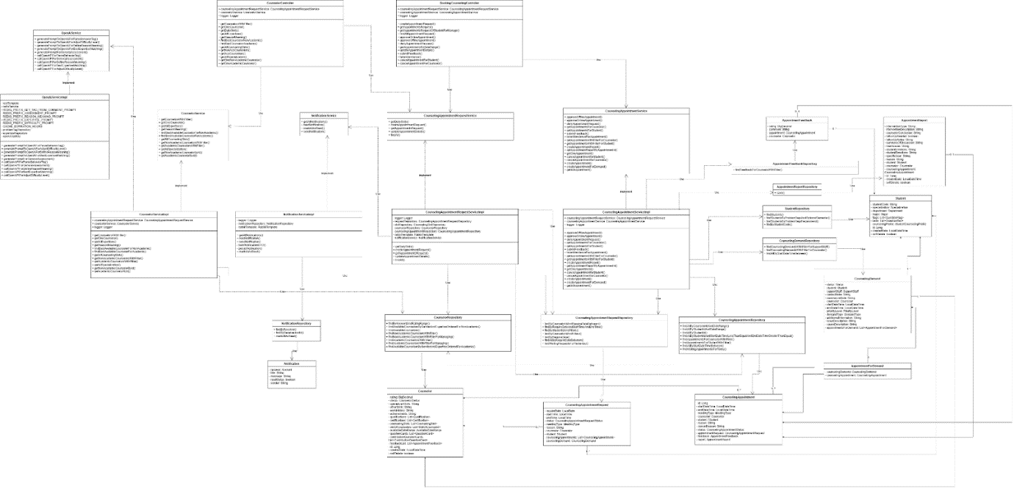

##### 3.1.1.1. Class Specification

###### 3.1.1.1.1. CounselorController class

|  |  |  |  |  |
| --- | --- | --- | --- | --- |
| **No** | **Attribute** | **Data Type** | **Visibility** | **Description** |
| 1 | counselingAppointmentRequestService | CounselingAppointmentRequestService | Public |  |
| 2 | counselorService | CounselorService | Public |  |
| 3 | logger | Logger | Public |  |

|  |  |  |  |
| --- | --- | --- | --- |
| **No** | **Method** | **Visibility** | **Description** |
| 1 | createAppointmentRequest() | Public |  |
| 2 | getAppointmentsRequest() | Public |  |
| 3 | getAppointmentsRequestOfStudentForManage() | Public |  |
| 4 | findAllAppointmentRequest() | Public |  |
| 5 | approveOnlineAppointment() | Public |  |
| 6 | approveOfflineAppointment() | Public |  |
| 7 | denyAppointmentRequest() | Public |  |
| 8 | getAppointmentsByDateRange() | Public |  |
| 9 | updateAppointmentDetails() | Public |  |
| 10 | submitFeedback() | Public |  |
| 11 | takeAttendance() | Public |  |
| 12 | cancelAppointmentForStudent() | Public |  |
| 13 | cancelAppointmentForCounselor() | Public |  |

###### 3.1.1.1.2. CounselorService class

|  |  |  |  |
| --- | --- | --- | --- |
| **No** | **Method** | **Visibility** | **Description** |
| 1 | getCounselorsWithFilter() | Public |  |
| 2 | getOneCounselor() | Public |  |
| 3 | getAllExpertises() | Public |  |
| 4 | getReasonMeaning() | Public |  |
| 5 | findBestAvailableCounselorForNonAcademic() | Public |  |
| 6 | findBestAvailableCounselorForAcademic() | Public |  |
| 7 | getAllCounselingSlots() | Public |  |
| 8 | getNonAcademicCounselorsWithFilter() | Public |  |
| 9 | getAcademicCounselorsWithFilter() | Public |  |
| 10 | getAllSpecialization() | Public |  |
| 11 | getNonAcademicCounselorById() | Public |  |
| 12 | getAcademicCounselorById() | Public |  |

###### 3.1.1.1.3. CounselorServiceImpl class

|  |  |  |  |  |
| --- | --- | --- | --- | --- |
| **No** | **Attribute** | **Data Type** | **Visibility** | **Description** |
| 1 | counselingAppointmentRequestService | CounselingAppointmentRequestService | Public |  |
| 2 | logger | Logger | Public |  |

|  |  |  |  |
| --- | --- | --- | --- |
| **No** | **Method** | **Visibility** | **Description** |
| 1 | getCounselorsWithFilter() | Public |  |
| 2 | getOneCounselor() | Public |  |
| 3 | getAllExpertises() | Public |  |
| 4 | getReasonMeaning() | Public |  |
| 5 | findBestAvailableCounselorForNonAcademic() | Public |  |
| 6 | findBestAvailableCounselorForAcademic() | Public |  |
| 7 | getAllCounselingSlots() | Public |  |
| 8 | getNonAcademicCounselorsWithFilter() | Public |  |
| 9 | getAcademicCounselorsWithFilter() | Public |  |
| 10 | getAllSpecialization() | Public |  |
| 11 | getAllSpecialization() | Public |  |
| 12 | getNonAcademicCounselorById() | Public |  |
| 13 | getAcademicCounselorById() | Public |  |

###### 3.1.1.1.4. NotificationServiceImpl class

|  |  |  |  |  |
| --- | --- | --- | --- | --- |
| **No** | **Attribute** | **Data Type** | **Visibility** | **Description** |
| 1 | logger | Logger | Private |  |
| 2 | notificationRepository | NotificationRepository | Private |  |
| 3 | rabbitTemplate | RabbitTemplate | Private |  |

|  |  |  |  |
| --- | --- | --- | --- |
| **No** | **Method** | **Visibility** | **Description** |
| 1 | getAllNotifications() | Public |  |
| 2 | readNotification() | Public |  |
| 3 | sendNotification() | Public |  |
| 4 | buildNotificationDTO() | Private |  |
| 5 | persistNotification() | Private |  |
| 6 | markAllAsRead() | Public |  |

###### 3.1.1.1.5. CounselingAppointmentRequestServiceImpl class

|  |  |  |  |  |
| --- | --- | --- | --- | --- |
| **No** | **Attribute** | **Data Type** | **Visibility** | **Description** |
| 1 | logger | Logger | Private |  |
| 2 | requestRepository | CounselingAppointmentRequestRepository | Private |  |
| 3 | slotRepository | CounselingSlotRepository | Private |  |
| 4 | counselorRepository | CounselorRepository | Private |  |
| 5 | counselingAppointmentRepository | CounselingAppointmentRepository | Private |  |
| 6 | rabbitTemplate | RabbitTemplate | Private |  |
| 7 | notificationService | NotificationService | Private |  |

|  |  |  |  |
| --- | --- | --- | --- |
| **No** | **Method** | **Visibility** | **Description** |
| 1 | getDailySlots() | Public |  |
| 2 | createAppointmentRequest() | Public |  |
| 3 | getAppointmentsRequest() | Public |  |
| 4 | updateAppointmentDetails() | Public |  |
| 5 | findAll() | Public |  |

###### 3.1.1.1.6. BookingCounselingController class

|  |  |  |  |  |
| --- | --- | --- | --- | --- |
| **No** | **Attribute** | **Data Type** | **Visibility** | **Description** |
| 1 | counselingAppointmentRequestService | CounselingAppointmentRequestService | Public |  |
| 2 | counselingAppointmentService | CounselingAppointmentService | Public |  |
| 3 | logger | Logger | Public |  |

|  |  |  |  |
| --- | --- | --- | --- |
| **No** | **Method** | **Visibility** | **Description** |
| 1 | createAppointmentRequest() | Public |  |
| 2 | getAppointmentsRequest() | Public |  |
| 3 | getAppointmentsRequestOfStudentForManage() | Public |  |
| 4 | findAllAppointmentRequest() | Public |  |
| 5 | approveOnlineAppointment() | Public |  |
| 6 | approveOfflineAppointment() | Public |  |
| 7 | denyAppointmentRequest() | Public |  |
| 8 | getAppointmentsByDateRange() | Public |  |
| 9 | updateAppointmentDetails() | Public |  |
| 10 | submitFeedback() | Public |  |
| 11 | takeAttendance() | Public |  |
| 12 | cancelAppointmentForStudent() | Public |  |
| 13 | cancelAppointmentForCounselor() | Public |  |

###### 3.1.1.1.7. CounselorRepository class

|  |  |  |  |
| --- | --- | --- | --- |
| **No** | **Method** | **Visibility** | **Description** |
| 1 | findByKeywordAndRatingRange() | Public |  |
| 2 | findAvailableCounselorsByGenderAndExpertiseOrderedForNonAcademic() | Public |  |
| 3 | findAvailableCounselors() | Public |  |
| 4 | findNonAcademicCounselorsWithFilter() | Public |  |
| 5 | findNonAcademicCounselorsWithFilterForManaging() | Public |  |
| 6 | findAcademicCounselorsWithFilter() | Public |  |
| 7 | findAcademicCounselorsWithFilterForManaging() | Public |  |
| 8 | findAvailableCounselorsByGenderAndExpertiseOrderedForAcademic() | Public |  |

###### 3.1.1.1.8. CounselingAppointmentRequestService class

|  |  |  |  |
| --- | --- | --- | --- |
| **No** | **Method** | **Visibility** | **Description** |
| 1 | getDailySlots() | Public |  |
| 2 | createAppointmentRequest() | Public |  |
| 3 | getAppointmentsRequest() | Public |  |
| 4 | updateAppointmentDetails() | Public |  |
| 5 | findAll() | Public |  |

###### 3.1.1.1.9. OpenAIServiceImpl class

|  |  |  |  |  |
| --- | --- | --- | --- | --- |
| **No** | **Attribute** | **Data Type** | **Visibility** | **Description** |
| 1 | restTemplate |  | Private |  |
| 2 | redisService |  | Private |  |
| 3 | REDIS_PREFIX_GET_TAG_FROM_COMMENT_PROMPT |  | Private |  |
| 4 | REDIS_PREFIX_ASSESSMENT_PROMPT |  | Private |  |
| 5 | REDIS_PREFIX_REASON_MEANING_PROMPT |  | Private |  |
| 6 | REDIS_PREFIX_EXPERTISE_PROMPT |  | Private |  |
| 7 | REDIS_PREFIX_DIFFICULTY_PROMPT |  | Private |  |
| 8 | CACHE_EXPIRATION_HOURS |  | Private |  |
| 9 | problemTagRepository |  | Private |  |
| 10 | expertiseRepository |  | Private |  |
| 11 | openAiApiKey |  | Private |  |

|  |  |  |  |
| --- | --- | --- | --- |
| **No** | **Method** | **Visibility** | **Description** |
| 1 | generatePromptToOpenAIForParseBehaviorTag() | Public |  |
| 2 | generatePromptToOpenAIForAdjustDifficultyLevel() | Public |  |
| 3 | generatePromptToOpenAIForDefineReasonMeaning() | Public |  |
| 4 | generatePromptToOpenAIForBestExpertiseMatching() | Public |  |
| 5 | generatePromptForGeneralAssessment() | Public |  |
| 6 | callOpenAPIForParseBehaviorTag() | Public |  |
| 7 | callOpenAPIForGeneralAssessment() | Public |  |
| 8 | callOpenAPIForDefineReasonMeaning() | Public |  |
| 9 | callOpenAPIForBestExpertiseMatching() | Public |  |
| 10 | callOpenAPIForAdjustDifficultyLevel() | Public |  |

###### 3.1.1.1.10. OpenAIServiceImpl class

|  |  |  |  |
| --- | --- | --- | --- |
| **No** | **Method** | **Visibility** | **Description** |
| 1 | generatePromptToOpenAIForParseBehaviorTag() | Public |  |
| 2 | generatePromptToOpenAIForAdjustDifficultyLevel() | Public |  |
| 3 | generatePromptToOpenAIForDefineReasonMeaning() | Public |  |
| 4 | generatePromptToOpenAIForBestExpertiseMatching() | Public |  |
| 5 | generatePromptForGeneralAssessment() | Public |  |
| 6 | callOpenAPIForParseBehaviorTag() | Public |  |
| 7 | callOpenAPIForGeneralAssessment() | Public |  |
| 8 | callOpenAPIForDefineReasonMeaning() | Public |  |
| 9 | callOpenAPIForBestExpertiseMatching() | Public |  |
| 10 | callOpenAPIForAdjustDifficultyLevel() | Public |  |

###### 3.1.1.1.11. NotificationService class

|  |  |  |  |
| --- | --- | --- | --- |
| **No** | **Method** | **Visibility** | **Description** |
| 1 | getAllNotifications() |  |  |
| 2 | readNotification() |  |  |
| 3 | markAllAsRead() |  |  |
| 4 | sendNotification() |  |  |

###### 3.1.1.1.12. OpenAIService class

|  |  |  |  |  |
| --- | --- | --- | --- | --- |
| **No** | **Attribute** | **Data Type** | **Visibility** | **Description** |
| 1 | restTemplate |  | Private |  |
| 2 | redisService |  | Private |  |
| 3 | REDIS_PREFIX_GET_TAG_FROM_COMMENT_PROMPT |  | Private |  |
| 4 | REDIS_PREFIX_ASSESSMENT_PROMPT |  | Private |  |
| 5 | REDIS_PREFIX_REASON_MEANING_PROMPT |  | Private |  |
| 6 | REDIS_PREFIX_EXPERTISE_PROMPT |  | Private |  |
| 7 | REDIS_PREFIX_DIFFICULTY_PROMPT |  | Private |  |
| 8 | CACHE_EXPIRATION_HOURS |  | Private |  |
| 9 | problemTagRepository |  | Private |  |
| 10 | expertiseRepository |  | Private |  |
| 11 | openAiApiKey |  | Private |  |

|  |  |  |  |
| --- | --- | --- | --- |
| **No** | **Method** | **Visibility** | **Description** |
| 1 | generatePromptToOpenAIForParseBehaviorTag() | Public |  |
| 2 | generatePromptToOpenAIForAdjustDifficultyLevel() | Public |  |
| 3 | generatePromptToOpenAIForDefineReasonMeaning() | Public |  |
| 4 | generatePromptToOpenAIForBestExpertiseMatching() | Public |  |
| 5 | generatePromptForGeneralAssessment() | Public |  |
| 6 | callOpenAPIForParseBehaviorTag() | Public |  |
| 7 | callOpenAPIForGeneralAssessment() | Public |  |
| 8 | callOpenAPIForDefineReasonMeaning() | Public |  |
| 9 | callOpenAPIForBestExpertiseMatching() | Public |  |
| 10 | callOpenAPIForAdjustDifficultyLevel() | Public |  |

###### 3.1.1.1.13. NotificationRepository class

|  |  |  |  |
| --- | --- | --- | --- |
| **No** | **Method** | **Visibility** | **Description** |
| 1 | findByReceiver() | Public |  |
| 2 | findByReceiverAndId() | Public |  |
| 3 | markAllAsRead() | Public |  |

###### 3.1.1.1.14. Notification class

|  |  |  |  |  |
| --- | --- | --- | --- | --- |
| **No** | **Attribute** | **Data Type** | **Visibility** | **Description** |
| 1 | receiver | Account | Private |  |
| 2 | title | String | Private |  |
| 3 | message | String | Private |  |
| 4 | readStatus | boolean | Private |  |
| 5 | sender | String | Private |  |

###### 3.1.1.1.15 . CounselingAppointmentService class

|  |  |  |  |
| --- | --- | --- | --- |
| **No** | **Method** | **Visibility** | **Description** |
| 1 | approveOfflineAppointment() | Public |  |
| 2 | approveOnlineAppointment() | Public |  |
| 3 | denyAppointmentRequest() | Public |  |
| 4 | getAppointmentsForCounselor() | Public |  |
| 5 | getAppointmentsForStudent() | Public |  |
| 6 | submitFeedback() | Public |  |
| 7 | takeAttendanceForAppointment() | Public |  |
| 8 | getAppointmentsWithFilterForCounselor() | Public |  |
| 9 | getAppointmentsWithFilterForStudent() | Public |  |
| 10 | createAppointmentReport() | Public |  |
| 11 | getAppointmentReportByAppointmentId() | Public |  |
| 12 | getOneAppointment() | Public |  |
| 13 | cancelAppointmentforStudent() | Public |  |
| 14 | cancelAppointmentforCounselor() | Public |  |
| 15 | createAppointment() | Public |  |
| 16 | createAppointmentForDemand() | Public |  |
| 17 | getAllAppointment() | Public |  |

###### 3.1.1.1.16 . CounselingAppointmentServiceImpl class

|  |  |  |  |  |
| --- | --- | --- | --- | --- |
| **No** | **Attribute** | **Data Type** | **Visibility** | **Description** |
| 1 | counselingAppointmentRequestService | CounselingAppointmentRequestService | Public |  |
| 2 | counselingAppointmentService | CounselingAppointmentService | Public |  |
| 3 | logger | Logger | Public |  |

|  |  |  |  |
| --- | --- | --- | --- |
| **No** | **Method** | **Visibility** | **Description** |
| 1 | approveOfflineAppointment() | Public |  |
| 2 | approveOnlineAppointment() | Public |  |
| 3 | denyAppointmentRequest() | Public |  |
| 4 | createAppointmentReport() | Public |  |
| 5 | getAppointmentsForCounselor() | Public |  |
| 6 | getAppointmentsForStudent() | Public |  |
| 7 | submitFeedback() | Public |  |
| 8 | takeAttendanceForAppointment() | Public |  |
| 9 | getAppointmentsWithFilterForCounselor() | Public |  |
| 10 | getAppointmentsWithFilterForStudent() | Public |  |
| 11 | getAppointmentReportByAppointmentId() | Public |  |
| 12 | getOneAppointment() | Public |  |
| 13 | cancelAppointmentforStudent() | Public |  |
| 14 | cancelAppointmentforCounselor() | Public |  |
| 15 | createAppointment() | Public |  |
| 16 | createAppointmentForDemand() | Public |  |
| 17 | getAllAppointment() | Public |  |

###### 3.1.1.1.17 . AppointmentFeedback class

|  |  |  |  |  |
| --- | --- | --- | --- | --- |
| **No** | **Attribute** | **Data Type** | **Visibility** | **Description** |
| 1 | rating | BigDecimal | Private |  |
| 2 | comment | String | Private |  |
| 3 | appointment | CounselingAppointment | Private |  |
| 4 | counselor | Counselor | Private |  |

###### 3.1.1.1.18 . AppointmentFeedbackRepository class

|  |  |  |  |
| --- | --- | --- | --- |
| **No** | **Method** | **Visibility** | **Description** |
| 1 | findFeedbackForCounselorWithFilter() | Public |  |

###### 3.1.1.1.19 . AppointmentReportRepository class

|  |  |  |  |
| --- | --- | --- | --- |
| **No** | **Method** | **Visibility** | **Description** |
| 1 | save() | Public |  |

###### 3.1.1.1.20 . AppointmentReport class

|  |  |  |  |  |
| --- | --- | --- | --- | --- |
| **No** | **Attribute** | **Data Type** | **Visibility** | **Description** |
| 1 | interventionType | String | Private |  |
| 2 | interventionDescription | String | Private |  |
| 3 | counselorConclusion | String | Private |  |
| 4 | followUpNeeded | boolean | Private |  |
| 5 | followUpNotes | String | Private |  |
| 6 | summaryOfDiscussion | String | Private |  |
| 7 | mainIssues | String | Private |  |
| 8 | studentEmotions | String | Private |  |
| 9 | studentReactions | String | Private |  |
| 10 | specificGoal | String | Private |  |
| 11 | reason | String | Private |  |
| 12 | student | Student | Private |  |
| 13 | counselor | Counselor | Private |  |
| 14 | counselingAppointment | List<CounselingAppointment> | Private |  |
| 15 | id | Long | Private |  |
| 16 | createdDate | LocalDateTime | Private |  |
| 17 | softDelete | boolean | Private |  |

###### 3.1.1.1.21 . CounselingAppointmentRequestRepository class

|  |  |  |  |
| --- | --- | --- | --- |
| **No** | **Method** | **Visibility** | **Description** |
| 1 | findByCounselorIdAndRequireDateBetween() | Public |  |
| 2 | findByRequireDateAndStartTimeAndEndTime() | Public |  |
| 3 | findByStudentIdAndFilters() | Public |  |
| 4 | findByCounselorIdAndFilters() | Public |  |
| 5 | findByRequireDate() | Public |  |
| 6 | findAllByRequireDateBetween() | Public |  |
| 7 | findWaitingRequestsForYesterday() | Public |  |

###### 3.1.1.1.22. Counselor class

|  |  |  |  |  |
| --- | --- | --- | --- | --- |
| **No** | **Attribute** | **Data Type** | **Visibility** | **Description** |
| 1 | rating | BigDecimal | Private |  |
| 2 | status | CounselorStatus | Private |  |
| 3 | specializedSkills | String | Private |  |
| 4 | otherSkills | String | Private |  |
| 5 | workHistory | String | Private |  |
| 6 | achievements | String | Private |  |
| 7 | qualifications | List<Qualification> | Private |  |
| 8 | certifications | List<Certification> | Private |  |
| 9 | counselingSlots | List<CounselingSlot> | Private |  |
| 10 | slotOfCounselors | List<SlotOfCounselor> | Private |  |
| 11 | availableDateRange | AvailableDateRange | Private |  |
| 12 | questionCards | List<QuestionCard> | Private |  |
| 13 | contributionQuestionCards | List<ContributionQuestionCard> | Private |  |
| 14 | feedbackList | List<AppointmentFeedback> | Private |  |
| 15 | id | Long | Private |  |
| 16 | createdDate | LocalDateTime | Private |  |
| 17 | softDelete | boolean | Private |  |

###### 3.1.1.1.23. CounselingAppointmentRequest class

|  |  |  |  |  |
| --- | --- | --- | --- | --- |
| **No** | **Attribute** | **Data Type** | **Visibility** | **Description** |
| 1 | requireDate | LocalDate | Private |  |
| 2 | startTime | LocalTime | Private |  |
| 3 | endTime | LocalTime | Private |  |
| 4 | status | CounselingAppointmentRequestStatus | Private |  |
| 5 | meetingType | MeetingType | Private |  |
| 6 | reason | String | Private |  |
| 7 | counselor | Counselor | Private |  |
| 8 | student | Student | Private |  |
| 9 | counselingAppointments | List<CounselingAppointment> | Private |  |
| 10 | counselingDemand | CounselingDemand | Private |  |

###### 3.1.1.1.24 . CounselingAppointment class

|  |  |  |  |  |
| --- | --- | --- | --- | --- |
| **No** | **Attribute** | **Data Type** | **Visibility** | **Description** |
| 1 | id | Long | Private |  |
| 2 | startDateTime | LocalDateTime | Private |  |
| 3 | endDateTime | LocalDateTime | Private |  |
| 4 | meetingType | MeetingType | Private |  |
| 5 | counselor | Counselor | Private |  |
| 6 | student | Student | Private |  |
| 7 | reason | String | Private |  |
| 8 | cancelReason | String | Private |  |
| 9 | status | CounselingAppointmentStatus | Private |  |
| 10 | appointmentRequest | CounselingAppointmentRequest | Private |  |
| 11 | feedback | AppointmentFeedback | Private |  |
| 12 | report | AppointmentReport | Private |  |

###### 3.1.1.1.25. AppointmentForDemand class

|  |  |  |  |  |
| --- | --- | --- | --- | --- |
| **No** | **Attribute** | **Data Type** | **Visibility** | **Description** |
| 1 | counselingDemand: | CounselingDemand | Private |  |
| 2 | counselingAppointment | CounselingAppointment | Private |  |

###### 3.1.1.1.26 . StudentRepository class

|  |  |  |  |
| --- | --- | --- | --- |
| **No** | **Method** | **Visibility** | **Description** |
| 1 | findStudents() | Public |  |
| 2 | findStudentsByProblemTagsAndOptionalSemester() | Public |  |
| 3 | findStudentsByProblemTagsRecommend() | Public |  |
| 4 | findByStudentCode() | Public |  |

###### 3.1.1.1.27. CounselingDemandRepository class

|  |  |  |  |
| --- | --- | --- | --- |
| **No** | **Method** | **Visibility** | **Description** |
| 1 | findCounselingDemandsWithFilterForSupportStaff() | Public |  |
| 2 | findCounselingDemandsWithFilterForCounselor() | Public |  |
| 3 | findAllByStartDateTimeBetween() | Public |  |

###### 3.1.1.1.28. CounselingAppointmentRepository class

|  |  |  |  |
| --- | --- | --- | --- |
| **No** | **Method** | **Visibility** | **Description** |
| 1 | findAllByCounselorIdAndDateRange() | Public |  |
| 2 | findAllByStudentIdAndDateRange() | Public |  |
| 3 | findAllByStudentId() | Public |  |
| 4 | findAllByStudentIdAndStartDateTimeLessThanEqualAndEndDateTimeGreaterThanEqual() | Public |  |
| 5 | findAppointmentsForCounselorWithFilter() | Public |  |
| 6 | findAppointmentsForStudentWithFilter() | Public |  |
| 7 | findAllByStartDateTimeBetween() | Public |  |
| 8 | findWaitingAppointmentsForToday() | Public |  |

###### 3.1.1.1.29 . Student class

|  |  |  |  |  |
| --- | --- | --- | --- | --- |
| **No** | **Attribute** | **Data Type** | **Visibility** | **Description** |
| 1 | studentCode | String | Private |  |
| 2 | specialization | Specialization | Private |  |
| 3 | department | Department | Private |  |
| 4 | major | Major | Private |  |
| 5 | flags | List<QuestionFlag> | Private |  |
| 6 | bans | List<QuestionBan> | Private |  |
| 7 | counselingProfile | StudentCounselingProfile | Private |  |
| 8 | id | Long | Private |  |
| 9 | createdDate | LocalDateTime | Private |  |
| 10 | softDelete | boolean | Private |  |

###### 3.1.1.1.30 . CounselingDemand class

|  |  |  |  |  |
| --- | --- | --- | --- | --- |
| **No** | **Attribute** | **Data Type** | **Visibility** | **Description** |
| 1 | status | Status | Private |  |
| 2 | student | Student | Private |  |
| 3 | supportStaff | SupportStaff | Private |  |
| 4 | contactNote | String | Private |  |
| 5 | summarizeNote | String | Private |  |
| 6 | counselor | Counselor | Private |  |
| 7 | startDateTime | LocalDateTime | Private |  |
| 8 | endDateTime | LocalDateTime | Private |  |
| 9 | priorityLevel | PriorityLevel | Private |  |
| 10 | demandType | DemandType | Private |  |
| 11 | additionalInformation | String | Private |  |
| 12 | issueDescription | String | Private |  |
| 13 | causeDescription | String | Private |  |
| 14 | appointmentsForDemand | List<AppointmentForDemand> | Private |  |

#### 3.1.2. Sequence Diagram

##### 3.1.2.1. Sequence Diagrarm

###### 3.1.2.1.1. Student quick matching counselor

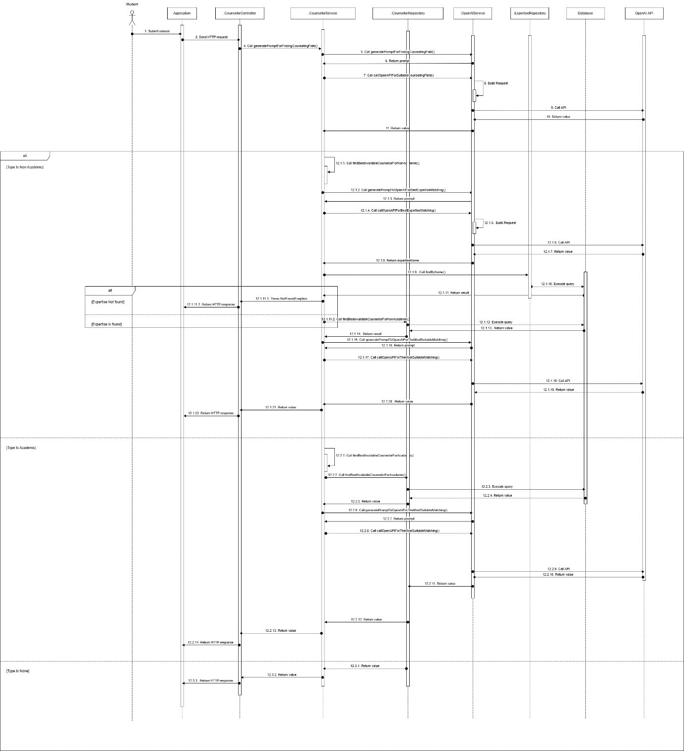

3.1.2.1.2. Student creates appointment request

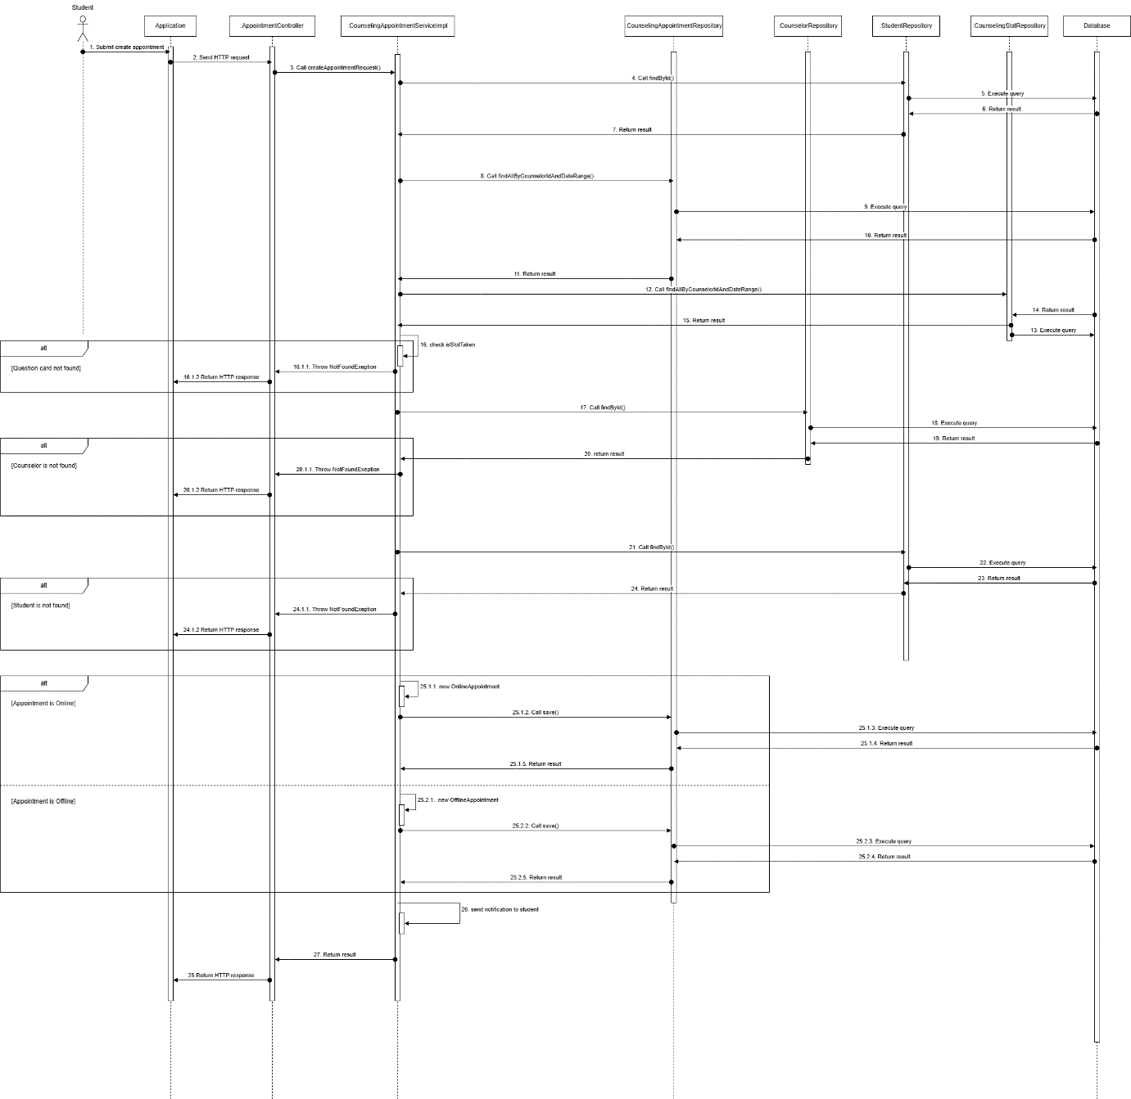

###### 3.1.2.1.3. Counselor approves appointment request

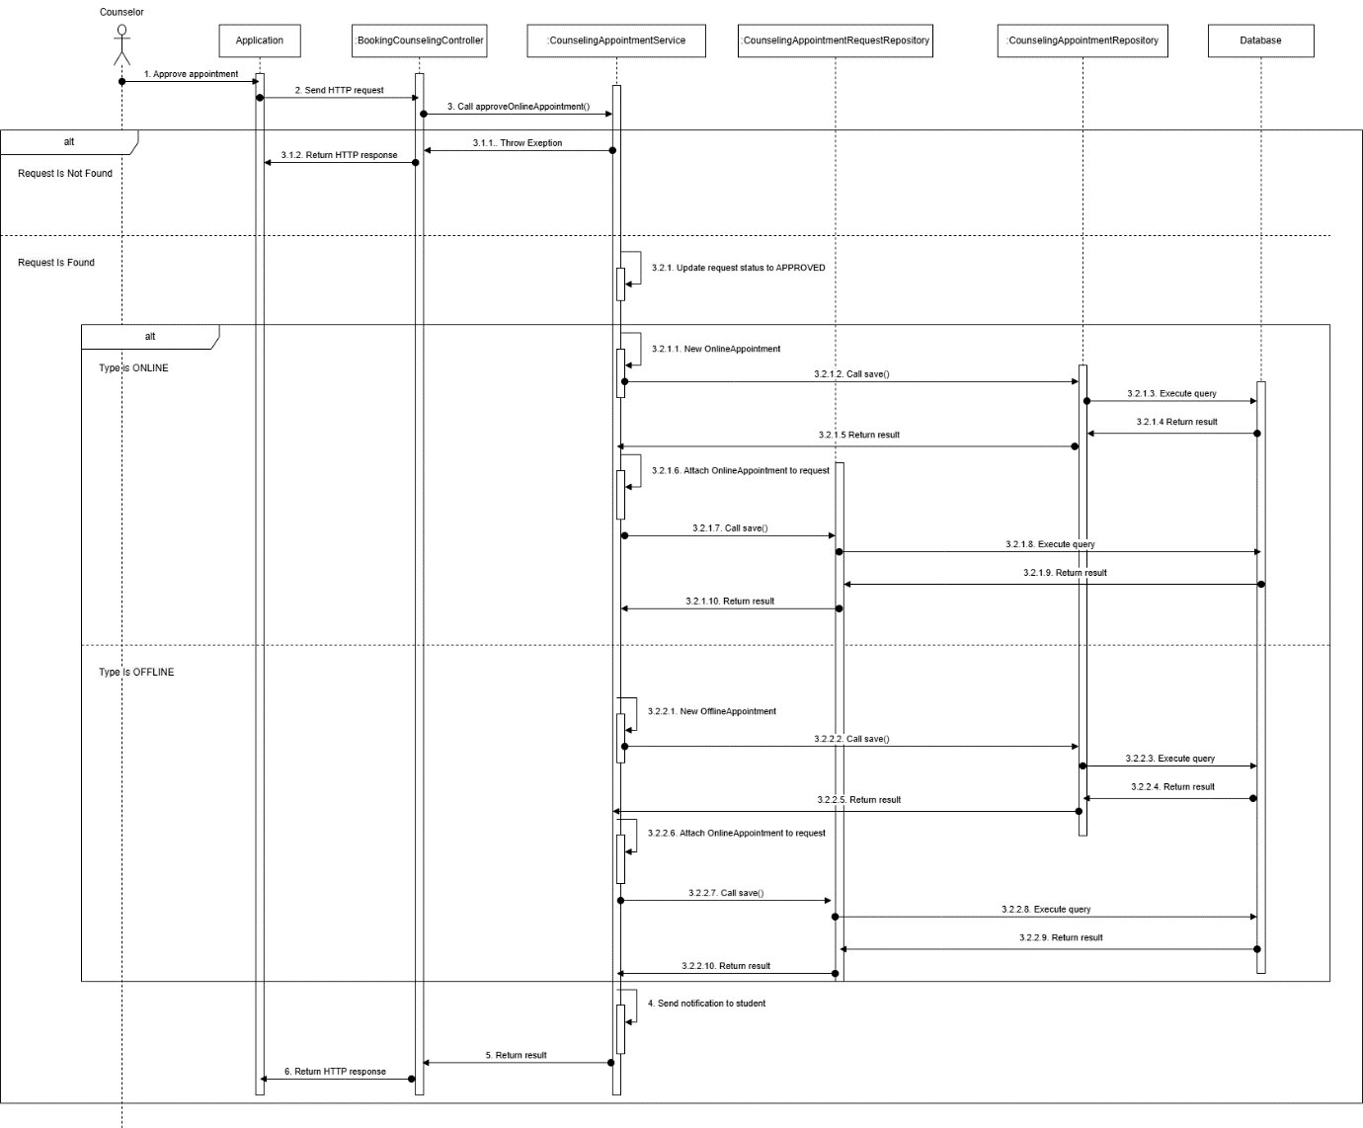

###### 3.1.2.1.4. Take attendance

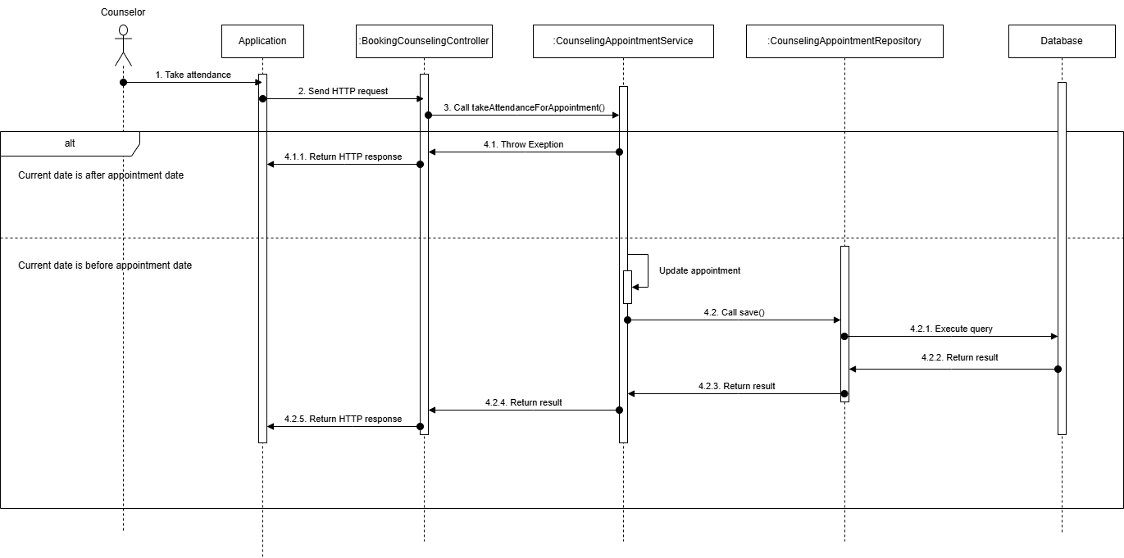

###### 3.1.2.1.5. Student provide feedback

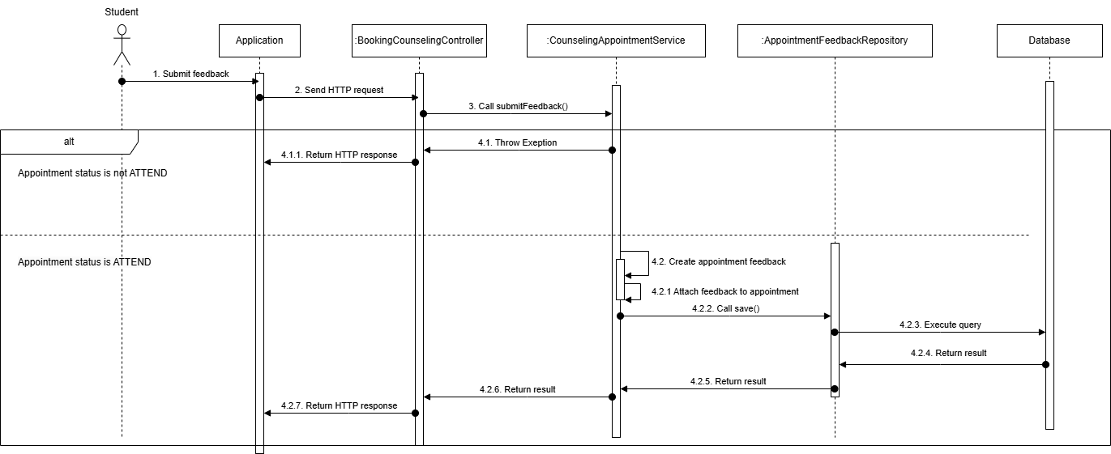

###### 3.1.2.1.6. Counselor cancel appointment

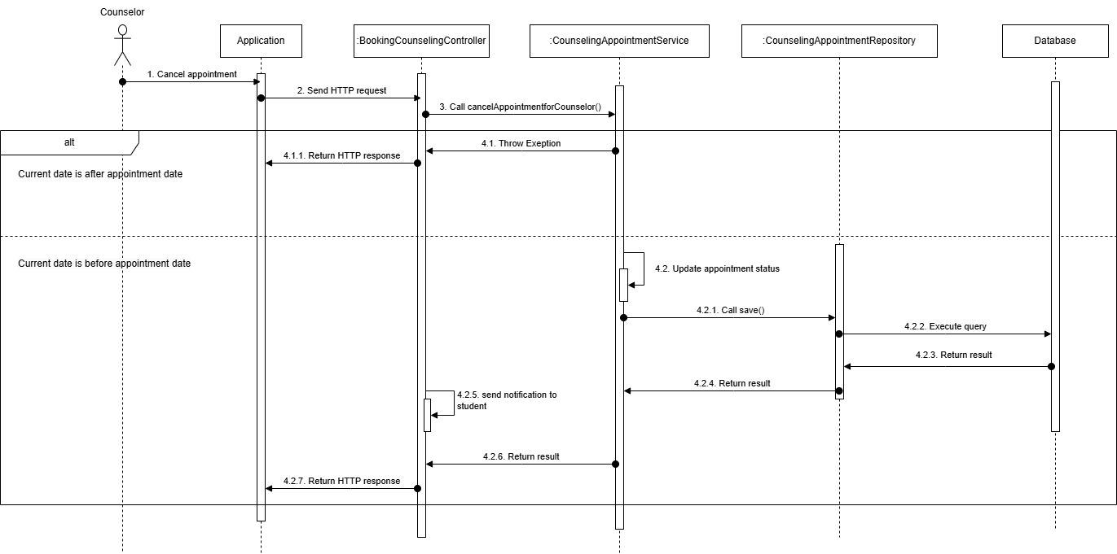

###### 3.1.2.1.7. Student cancel appointment

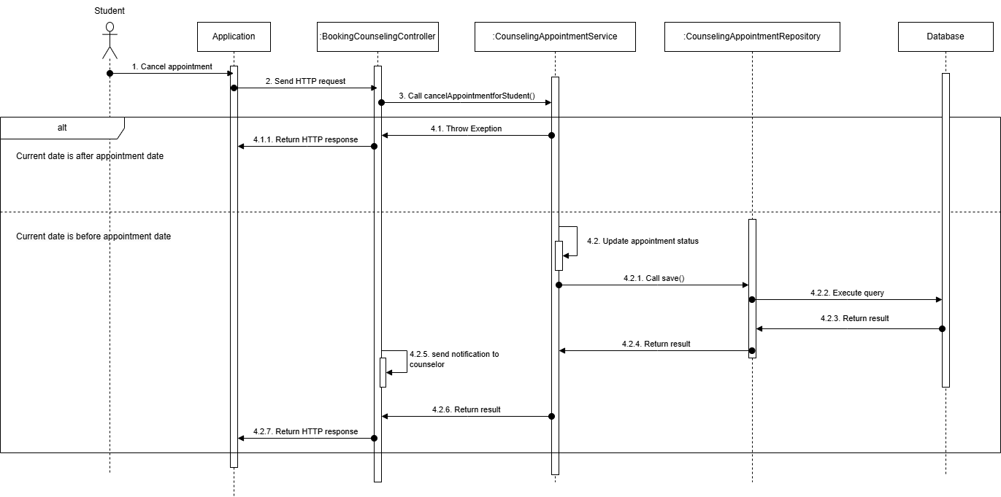

#### 3.1.3. Activity Diagram

3.1.3.1. Create Booking request with quick booking  
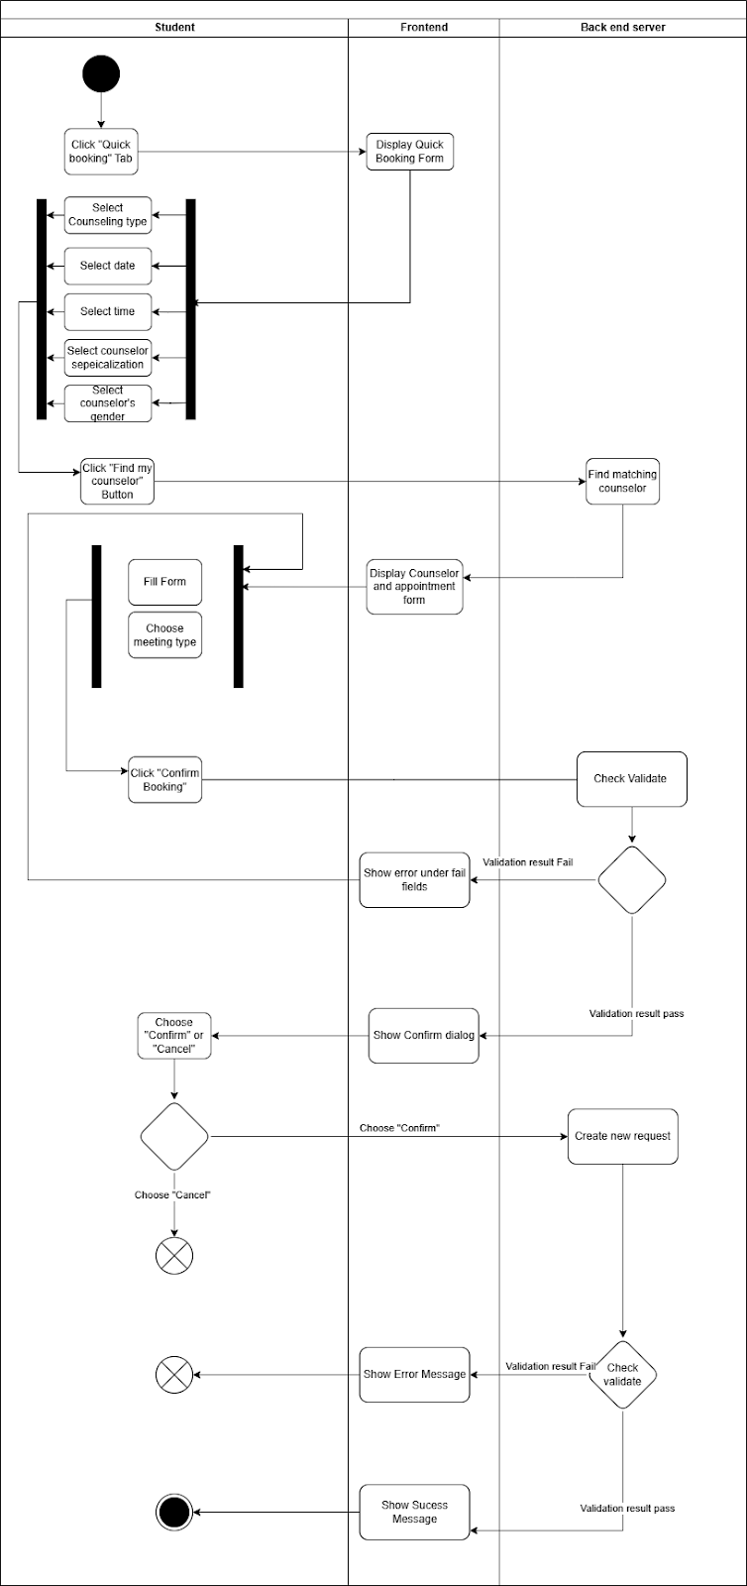

##### 3.1.3.2. Create booking request with choosing a specific counselor

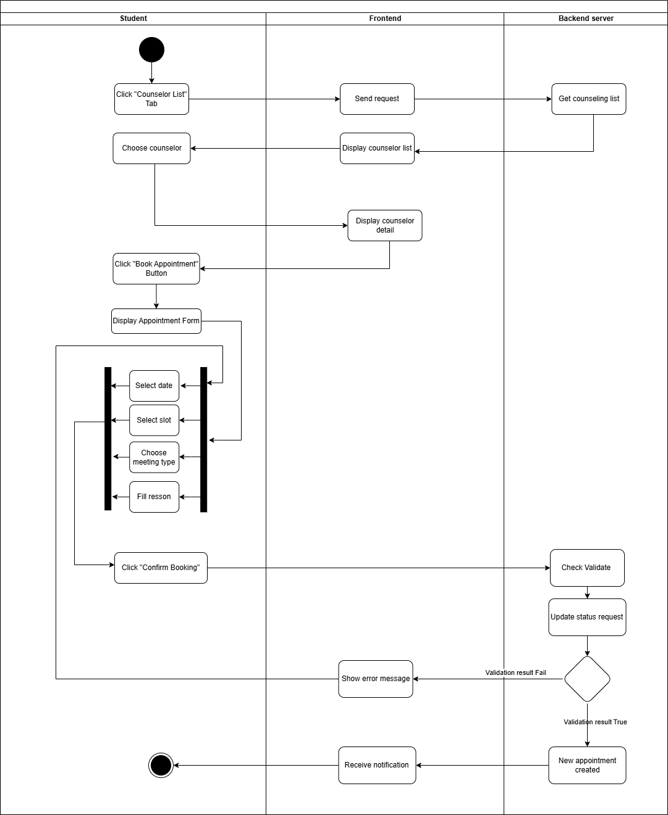

##### 3.1.3.3. Take attendance

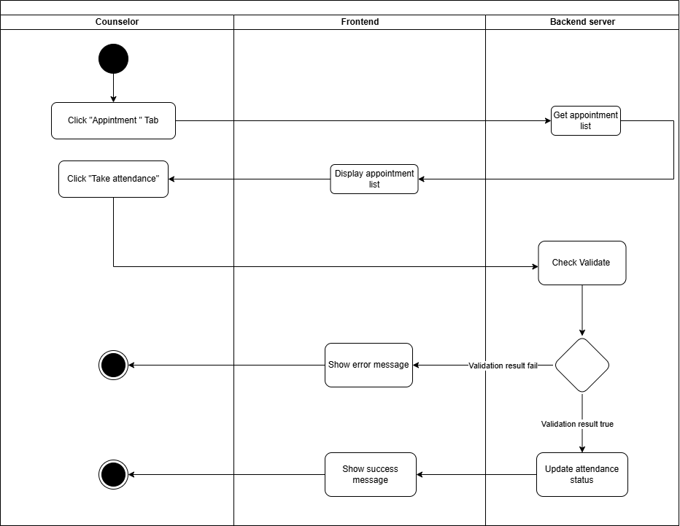

##### 3.1.3.4. Provide Feedback

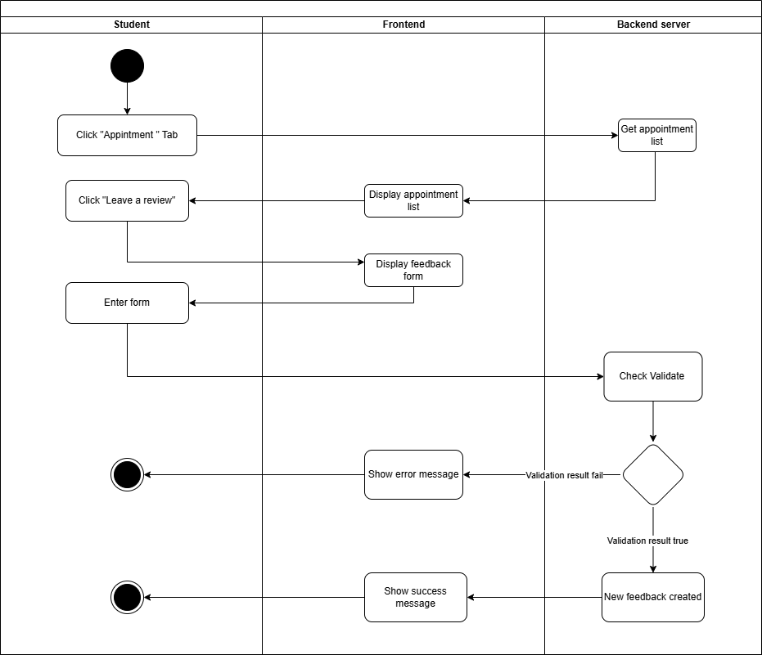

##### 3.1.3.5. Cancel Appointment

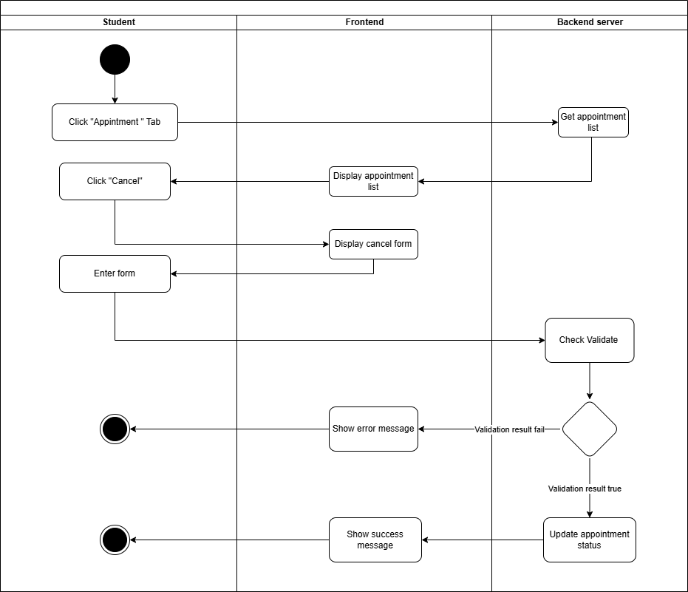

**3.1.3.6. Approve appointment request**

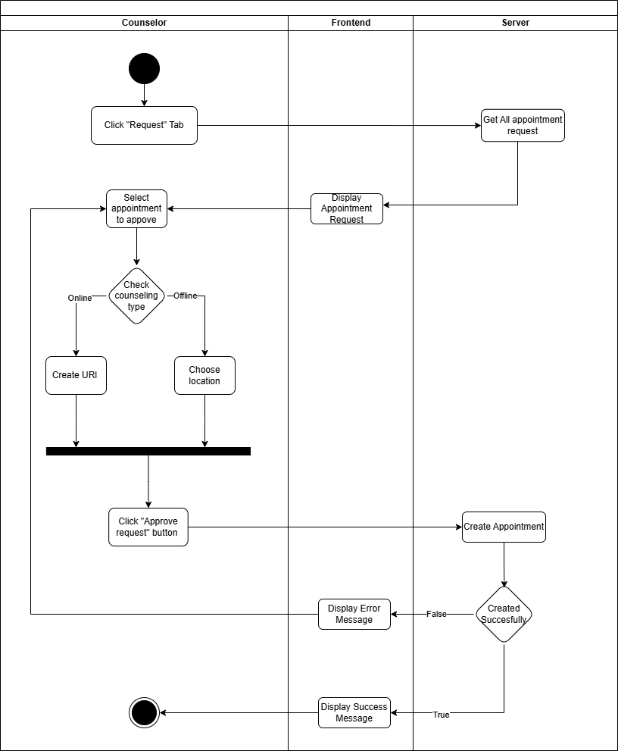

**3.1.3.7. Create report**

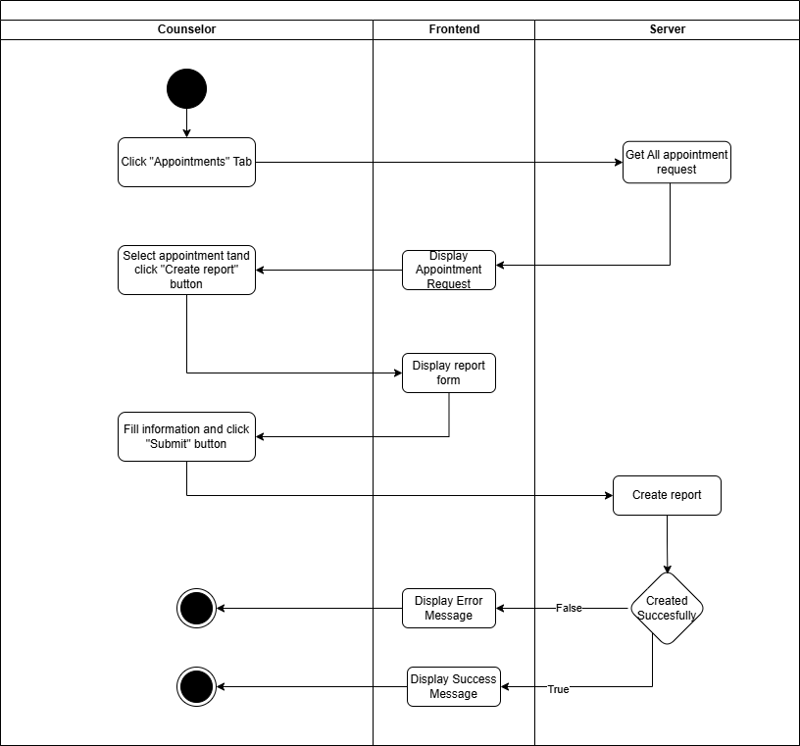

#### 3.1.4. State Machine Diagram

##### 3.1.4.1. Booking Appointment State Machine Diagram

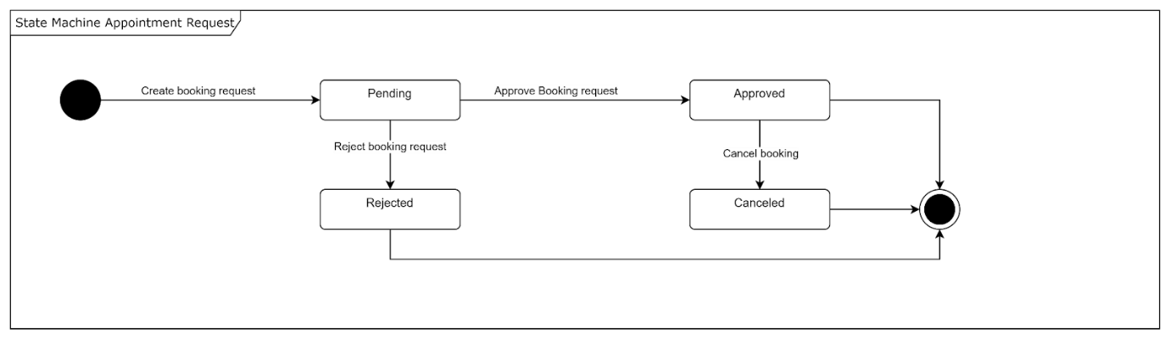

##### 3.1.4.2. Taking Appointment State Machine Diagram

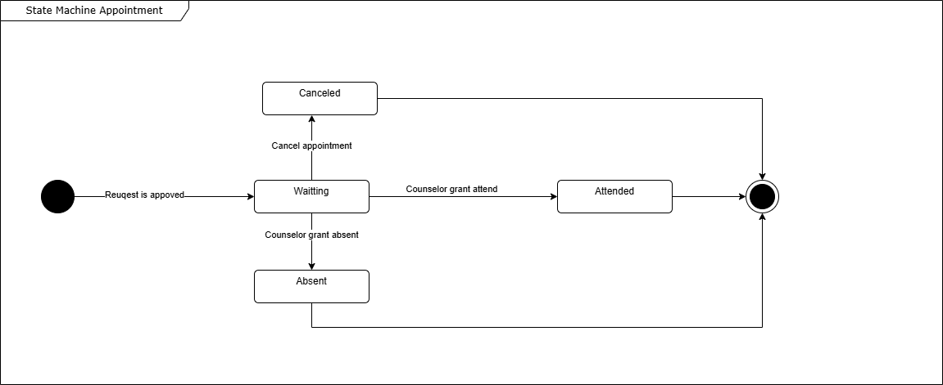

### 3.2. Student Questions and Counselor Support

#### 3.2.1. Class Diagram

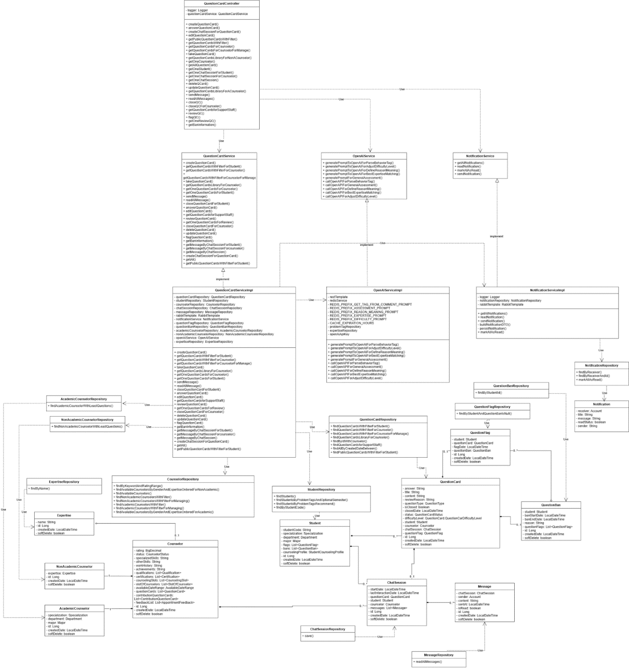

##### 3.2.1.1. Class Specification

###### 3.2.1.1.1. Counselor class

|  |  |  |  |  |
| --- | --- | --- | --- | --- |
| **No** | **Attribute** | **Data Type** | **Visibility** | **Description** |
| 1 | rating | BigDecimal | Private |  |
| 2 | status | CounselorStatus | Private |  |
| 3 | specializedSkills | String | Private |  |
| 4 | otherSkills | String | Private |  |
| 5 | workHistory | String | Private |  |
| 6 | achievements | String | Private |  |
| 7 | qualifications | List<Qualification> | Private |  |
| 8 | certifications | List<Certification> | Private |  |
| 9 | counselingSlots | List<CounselingSlot> | Private |  |
| 10 | slotOfCounselors | List<SlotOfCounselor> | Private |  |
| 11 | availableDateRange | AvailableDateRange | Private |  |
| 12 | questionCards | List<QuestionCard> | Private |  |
| 13 | contributionQuestionCards | List<ContributionQuestionCard> | Private |  |
| 14 | feedbackList | List<AppointmentFeedback> | Private |  |
| 15 | id | Long | Private |  |
| 16 | createdDate | LocalDateTime | Private |  |
| 17 | softDelete | boolean | Private |  |

###### 3.2.1.1.2 . StudentRepository class

|  |  |  |  |
| --- | --- | --- | --- |
| **No** | **Method** | **Visibility** | **Description** |
| 1 | findStudents() | Public |  |
| 2 | findStudentsByProblemTagsAndOptionalSemester() | Public |  |
| 3 | findStudentsByProblemTagsRecommend() | Public |  |
| 4 | findByStudentCode() | Public |  |

###### 3.2.1.1.3. CounselorRepository class

|  |  |  |  |
| --- | --- | --- | --- |
| **No** | **Method** | **Visibility** | **Description** |
| 1 | findByKeywordAndRatingRange() | Public |  |
| 2 | findAvailableCounselorsByGenderAndExpertiseOrderedForNonAcademic() | Public |  |
| 3 | findAvailableCounselors() | Public |  |
| 4 | findNonAcademicCounselorsWithFilter() | Public |  |
| 5 | findNonAcademicCounselorsWithFilterForManaging() | Public |  |
| 6 | findAcademicCounselorsWithFilter() | Public |  |
| 7 | findAcademicCounselorsWithFilterForManaging() | Public |  |
| 8 | findAvailableCounselorsByGenderAndExpertiseOrderedForAcademic() | Public |  |

###### 3.2.1.1.4. Student class

|  |  |  |  |  |
| --- | --- | --- | --- | --- |
| **No** | **Attribute** | **Data Type** | **Visibility** | **Description** |
| 1 | studentCode | String | Private |  |
| 2 | specialization | Specialization | Private |  |
| 3 | department | Department | Private |  |
| 4 | major | Major | Private |  |
| 5 | flags | List<QuestionFlag> | Private |  |
| 6 | bans | List<QuestionBan> | Private |  |
| 7 | counselingProfile | StudentCounselingProfile | Private |  |
| 8 | id | Long | Private |  |
| 9 | createdDate | LocalDateTime | Private |  |
| 10 | softDelete | boolean | Private |  |

###### 3.2.1.1.5. QuestionCard class

|  |  |  |  |  |
| --- | --- | --- | --- | --- |
| **No** | **Attribute** | **Data Type** | **Visibility** | **Description** |
| 1 | answer | String | Private |  |
| 2 | title | String | Private |  |
| 3 | content | String | Private |  |
| 4 | reviewReason | String | Private |  |
| 5 | questionType | QuestionType | Private |  |
| 6 | isClosed | boolean | Private |  |
| 7 | closedDate | LocalDateTime | Private |  |
| 8 | status | QuestionCardStatus | Private |  |
| 9 | difficultyLevel: | LocalDateTime | Private |  |
| 10 | QuestionCard | QuestionCarDifficultyLevel | Private |  |
| 11 | student | Student | Private |  |
| 12 | counselor | Counselor | Private |  |
| 13 | chatSession | ChatSession | Private |  |
| 14 | questionFlag | QuestionFlag | Private |  |
| 15 | id | Long | Private |  |
| 16 | createdDate | LocalDateTime | Private |  |
| 17 | softDelete | boolean | Private |  |

###### 3.2.1.1.6. QuestionBan class

|  |  |  |  |  |
| --- | --- | --- | --- | --- |
| **No** | **Attribute** | **Data Type** | **Visibility** | **Description** |
| 1 | student: | Student | Private |  |
| 2 | banStartDate | LocalDateTime | Private |  |
| 3 | banEndDate | LocalDateTime | Private |  |
| 4 | reason | String | Private |  |
| 5 | questionFlags | List<QuestionFlag> | Private |  |
| 6 | id | Long | Private |  |
| 7 | createdDate: | LocalDateTime | Private |  |
| 8 | softDelete: | boolean | Private |  |

###### 3.2.1.1.7. NotificationService class

|  |  |  |  |
| --- | --- | --- | --- |
| **No** | **Method** | **Visibility** | **Description** |
| 1 | getAllNotifications() | Public |  |
| 2 | readNotification() | Public |  |
| 3 | markAllAsRead() | Public |  |
| 4 | sendNotification() | Public |  |

###### 3.2.1.1.8. NotificationServiceImpl class

|  |  |  |  |  |
| --- | --- | --- | --- | --- |
| **No** | **Attribute** | **Data Type** | **Visibility** | **Description** |
| 1 | logger | Logger | Private |  |
| 2 | notificationRepository | NotificationRepository | Private |  |
| 3 | rabbitTemplate | RabbitTemplate | Private |  |

|  |  |  |  |
| --- | --- | --- | --- |
| **No** | **Method** | **Visibility** | **Description** |
| 1 | getAllNotifications() | Public |  |
| 2 | readNotification() | Public |  |
| 3 | sendNotification() | Public |  |
| 4 | buildNotificationDTO() | Private |  |
| 5 | persistNotification() | Private |  |
| 6 | markAllAsRead() | Public |  |

###### 3.2.1.1.9 . NotificationRepository class

|  |  |  |  |
| --- | --- | --- | --- |
| **No** | **Method** | **Visibility** | **Description** |
| 1 | findByReceiver() | Public |  |
| 2 | findByReceiverAndId() | Public |  |
| 3 | markAllAsRead() | Public |  |

###### 3.2.1.1.10. Notification class

|  |  |  |  |  |
| --- | --- | --- | --- | --- |
| **No** | **Attribute** | **Data Type** | **Visibility** | **Description** |
| 1 | receiver | Account | Private |  |
| 2 | title | String | Private |  |
| 3 | message | String | Private |  |
| 4 | readStatus | boolean | Private |  |
| 5 | sender | String | Private |  |

###### 3.2.1.1.11. ChatSession class

|  |  |  |  |  |
| --- | --- | --- | --- | --- |
| **No** | **Attribute** | **Data Type** | **Visibility** | **Description** |
| 1 | startDate | LocalDateTime | Private |  |
| 2 | startDate | LocalDateTime | Private |  |
| 3 | questionCard | QuestionCard | Private |  |
| 4 | student | Student | Private |  |
| 5 | counselor | Counselor | Private |  |
| 6 | messages | List<Message> | Private |  |
| 7 | id | Long | Private |  |
| 8 | createdDate | LocalDateTime | Private |  |
| 9 | softDelete | boolean | Private |  |

###### 3.2.1.1.12. Message class

|  |  |  |  |  |
| --- | --- | --- | --- | --- |
| **No** | **Attribute** | **Data Type** | **Visibility** | **Description** |
| 1 | chatSession | ChatSession | Private |  |
| 2 | sender | Account | Private |  |
| 3 | content | String | Private |  |
| 4 | sentAt | LocalDateTime | Private |  |
| 6 | isRead | boolean | Private |  |
| 7 | id | Long | Private |  |
| 8 | createdDate | LocalDateTime | Private |  |
| 9 | softDelete | boolean | Private |  |

###### 3.2.1.1.13. MessageRepository class

|  |  |  |  |
| --- | --- | --- | --- |
| **No** | **Method** | **Visibility** | **Description** |
| 1 | readAllMessages() | Public |  |

###### 3.2.1.1.14. MessageRepository class

|  |  |  |  |
| --- | --- | --- | --- |
| **No** | **Method** | **Visibility** | **Description** |
| 1 | save() | Public |  |

###### 3.2.1.1.15. QuestionFlag class

|  |  |  |  |  |
| --- | --- | --- | --- | --- |
| **No** | **Attribute** | **Data Type** | **Visibility** | **Description** |
| 1 | student | Student | Private |  |
| 2 | questionCard | QuestionCard | Private |  |
| 3 | flagDate | LocalDateTime | Private |  |
| 4 | questionBan | QuestionBan | Private |  |
| 6 | isRead | boolean | Private |  |
| 7 | id | Long | Private |  |
| 8 | createdDate | LocalDateTime | Private |  |
| 9 | softDelete | boolean | Private |  |

###### 3.2.1.1.16. QuestionFlagRepository class

|  |  |  |  |
| --- | --- | --- | --- |
| **No** | **Method** | **Visibility** | **Description** |
| 1 | findByStudentAndQuestionBanIsNull() | Public |  |

###### 3.2.1.1.17. QuestionBanRepository class

|  |  |  |  |
| --- | --- | --- | --- |
| **No** | **Method** | **Visibility** | **Description** |
| 1 | findByStudentId() | Public |  |

###### 3.2.1.1.18. QuestionCardServiceImpl class

|  |  |  |  |  |
| --- | --- | --- | --- | --- |
| **No** | **Attribute** | **Data Type** | **Visibility** | **Description** |
| 1 | questionCardRepository | QuestionCardRepository | Private |  |
| 2 | studentRepository | StudentRepository | Private |  |
| 3 | counselorRepository | CounselorRepository | Private |  |
| 4 | chatSessionRepository | ChatSessionRepository | Private |  |
| 5 | messageRepository | MessageRepository | Private |  |
| 6 | rabbitTemplate | RabbitTemplate | Private |  |
| 7 | notificationService | NotificationService | Private |  |
| 8 | questionFlagRepository | QuestionFlagRepository | Private |  |
| 9 | questionBanRepository | QuestionBanRepository | Private |  |
| 10 | academicCounselorRepository | AcademicCounselorRepository | Private |  |
| 11 | nonAcademicCounselorRepository | NonAcademicCounselorRepository | Private |  |
| 12 | openAIService | OpenAIService | Private |  |
| 13 | expertiseRepository | ExpertiseRepository | Private |  |

|  |  |  |  |
| --- | --- | --- | --- |
| **No** | **Method** | **Visibility** | **Description** |
| 1 | createQuestionCard() | Public |  |
| 2 | getQuestionCardsWithFilterForStudent() | Public |  |
| 3 | getQuestionCardsWithFilterForCounselor() | Public |  |
| 4 | getQuestionCardsWithFilterForCounselorForManage() | Public |  |
| 5 | takeQuestionCard() | Public |  |
| 6 | getQuestionCardsLibraryForCounselor() | Public |  |
| 7 | getOneQuestionCardsForCounselor() | Public |  |
| 8 | getOneQuestionCardsForStudent() | Public |  |
| 9 | sendMessage() | Public |  |
| 10 | readAllMessage() | Public |  |
| 11 | closeQuestionCardForStudent() | Public |  |
| 12 | answerQuestionCard() | Public |  |
| 13 | editQuestionCard() | Public |  |
| 14 | getQuestionCardsforSupportStaff() | Public |  |
| 15 | reviewQuestionCard() | Public |  |
| 16 | getOneQuestionCardsForReview() | Public |  |
| 17 | closeQuestionCardForCounselor() | Public |  |
| 18 | deleteQuestionCard() | Public |  |
| 19 | updateQuestionCard() | Public |  |
| 20 | flagQuestionCard() | Public |  |
| 21 | getBanInformation() | Public |  |
| 22 | getMessageByChatSessionForStudent() | Public |  |
| 23 | getMessageByChatSessionForCounselor() | Public |  |
| 24 | getMessageByChatSession() | Public |  |
| 25 | createChatSessionForQuestionCard() | Public |  |
| 26 | getAll() | Public |  |
| 27 | getPublicQuestionCardsWithFilterForStudent() | Public |  |

###### 3.2.1.1.19. QuestionCardController class

|  |  |  |  |  |
| --- | --- | --- | --- | --- |
| **No** | **Attribute** | **Data Type** | **Visibility** | **Description** |
| 1 | logger | Logger | Private |  |
| 2 | questionCardService | QuestionCardService | Private |  |

|  |  |  |  |
| --- | --- | --- | --- |
| **No** | **Method** | **Visibility** | **Description** |
| 1 | createQuestionCard() | Public |  |
| 2 | answerQuestionCard() | Public |  |
| 3 | createChatSessionForQuestionCard() | Public |  |
| 4 | editQuestionCard() | Public |  |
| 5 | getPublicQuestionCardsWithFilter() | Public |  |
| 6 | getQuestionCardsWithFilter() | Public |  |
| 7 | getQuestionCardsForCounselor() | Public |  |
| 8 | getQuestionCardsForCounselorForManage() | Public |  |
| 9 | takeQuestionCard() | Public |  |
| 10 | getQuestionCardsLibraryForNonACounselor() | Public |  |
| 11 | getOneCounselor() | Public |  |
| 12 | getAllQuestionCard() | Public |  |
| 13 | getOneStudent() | Public |  |
| 14 | getOneChatSessionForStudent() | Public |  |
| 15 | getOneChatSessionForCounselor() | Public |  |
| 16 | getOneChatSession() | Public |  |
| 17 | deleteQCard() | Public |  |
| 18 | updateQuestionCard() | Public |  |
| 19 | getQuestionCardsLibraryForACounselor() | Public |  |
| 20 | sendMessage() | Public |  |
| 21 | readAllMessages() | Public |  |
| 22 | closeQC() | Public |  |
| 23 | closeQCForCounselor() | Public |  |
| 24 | getQuestionCardsforSupportStaff() | Public |  |
| 25 | reviewQC() | Public |  |
| 26 | flagQC() | Public |  |
| 27 | getOneReviewQC() | Public |  |
| 28 | getBanInformation() | Public |  |

###### 3.2.1.1.20. QuestionCardController class

|  |  |  |  |
| --- | --- | --- | --- |
| **No** | **Method** | **Visibility** | **Description** |
| 1 | createQuestionCard() | Public |  |
| 2 | getQuestionCardsWithFilterForStudent() | Public |  |
| 3 | getQuestionCardsWithFilterForCounselor() | Public |  |
| 4 | getQuestionCardsWithFilterForCounselorForManage() | Public |  |
| 5 | takeQuestionCard() | Public |  |
| 6 | getQuestionCardsLibraryForCounselor() | Public |  |
| 7 | getOneQuestionCardsForCounselor() | Public |  |
| 8 | getOneQuestionCardsForStudent() | Public |  |
| 9 | sendMessage() | Public |  |
| 10 | readAllMessage() | Public |  |
| 11 | closeQuestionCardForStudent() | Public |  |
| 12 | answerQuestionCard() | Public |  |
| 13 | editQuestionCard() | Public |  |
| 14 | getQuestionCardsforSupportStaff() | Public |  |
| 15 | reviewQuestionCard() | Public |  |
| 16 | getOneQuestionCardsForReview() | Public |  |
| 17 | closeQuestionCardForCounselor() | Public |  |
| 18 | deleteQuestionCard() | Public |  |
| 19 | updateQuestionCard() | Public |  |
| 20 | flagQuestionCard() | Public |  |
| 21 | getBanInformation() | Public |  |
| 22 | getMessageByChatSessionForStudent() | Public |  |
| 23 | getMessageByChatSessionForcounselor() | Public |  |
| 24 | getMessageByChatSession() | Public |  |
| 25 | createChatSessionForQuestionCard() | Public |  |
| 26 | getAll() | Public |  |
| 27 | getPublicQuestionCardsWithFilterForStudent() | Public |  |

###### 3.2.1.1.21. OpenAIService class

|  |  |  |  |
| --- | --- | --- | --- |
| **No** | **Method** | **Visibility** | **Description** |
| 1 | generatePromptToOpenAIForParseBehaviorTag() | Public |  |
| 2 | generatePromptToOpenAIForAdjustDifficultyLevel() | Public |  |
| 3 | generatePromptToOpenAIForDefineReasonMeaning() | Public |  |
| 4 | generatePromptToOpenAIForBestExpertiseMatching() | Public |  |
| 5 | generatePromptForGeneralAssessment() | Public |  |
| 6 | callOpenAPIForParseBehaviorTag() | Public |  |
| 7 | callOpenAPIForGeneralAssessment() | Public |  |
| 8 | callOpenAPIForDefineReasonMeaning() | Public |  |
| 9 | callOpenAPIForBestExpertiseMatching() | Public |  |
| 10 | callOpenAPIForAdjustDifficultyLevel() | Public |  |

###### 3.2.1.1.22. QuestionCardRepository class

|  |  |  |  |
| --- | --- | --- | --- |
| **No** | **Method** | **Visibility** | **Description** |
| 1 | findQuestionCardsWithFilterForStudent() | Public |  |
| 2 | findQuestionCardsWithFilterForCounselor() | Public |  |
| 3 | findQuestionCardsWithFilterForCounselorForManage() | Public |  |
| 4 | findQuestionCardsLibraryForCounselor() | Public |  |
| 5 | findByIdWithCounselor() | Public |  |
| 6 | findQuestionCardsforSupportStaff() | Public |  |
| 7 | findAllByCreatedDateBetween() | Public |  |
| 8 | findPublicQuestionCardsWithFilterForStudent() | Public |  |

###### 3.2.1.1.23. OpenAIService class

|  |  |  |  |  |
| --- | --- | --- | --- | --- |
| **No** | **Attribute** | **Data Type** | **Visibility** | **Description** |
| 1 | restTemplate |  | Private |  |
| 2 | redisService |  | Private |  |
| 3 | REDIS_PREFIX_GET_TAG_FROM_COMMENT_PROMPT |  | Private |  |
| 4 | REDIS_PREFIX_ASSESSMENT_PROMPT |  | Private |  |
| 5 | REDIS_PREFIX_REASON_MEANING_PROMPT |  | Private |  |
| 6 | REDIS_PREFIX_EXPERTISE_PROMPT |  | Private |  |
| 7 | REDIS_PREFIX_DIFFICULTY_PROMPT |  | Private |  |
| 8 | CACHE_EXPIRATION_HOURS |  | Private |  |
| 9 | problemTagRepository |  | Private |  |
| 10 | expertiseRepository |  | Private |  |
| 11 | openAiApiKey |  | Private |  |

|  |  |  |  |
| --- | --- | --- | --- |
| **No** | **Method** | **Visibility** | **Description** |
| 1 | generatePromptToOpenAIForParseBehaviorTag() | Public |  |
| 2 | generatePromptToOpenAIForAdjustDifficultyLevel() | Public |  |
| 3 | generatePromptToOpenAIForDefineReasonMeaning() | Public |  |
| 4 | generatePromptToOpenAIForBestExpertiseMatching() | Public |  |
| 5 | generatePromptForGeneralAssessment() | Public |  |
| 6 | callOpenAPIForParseBehaviorTag() | Public |  |
| 7 | callOpenAPIForGeneralAssessment() | Public |  |
| 8 | callOpenAPIForDefineReasonMeaning() | Public |  |
| 9 | callOpenAPIForBestExpertiseMatching() | Public |  |
| 10 | callOpenAPIForAdjustDifficultyLevel() | Public |  |

###### 3.2.1.1.24. NonAcademicCounselor class

|  |  |  |  |  |
| --- | --- | --- | --- | --- |
| **No** | **Attribute** | **Data Type** | **Visibility** | **Description** |
| 1 | expertise | Expertise | Private |  |
| 2 | id | Long | Private |  |
| 3 | createdDate | LocalDateTime | Private |  |
| 4 | softDelete | boolean | Private |  |

###### 3.2.1.1.25. AcademicCounselor class

|  |  |  |  |  |
| --- | --- | --- | --- | --- |
| **No** | **Attribute** | **Data Type** | **Visibility** | **Description** |
| 1 | specialization | Specialization | Private |  |
| 2 | department | Department | Private |  |
| 3 | major | Major | Private |  |
| 4 | id | Long | Private |  |
| 5 | createdDate | LocalDateTime | Private |  |
| 6 | softDelete | boolean | Private |  |

###### 3.2.1.1.26. ExpertiseRepository class

|  |  |  |  |
| --- | --- | --- | --- |
| **No** | **Method** | **Visibility** | **Description** |
| 1 | findByName() | Public |  |

###### 3.2.1.1.27. AcademicCounselorRepository class

|  |  |  |  |
| --- | --- | --- | --- |
| **No** | **Method** | **Visibility** | **Description** |
| 1 | findAcademicCounselorWithLeastQuestions() | Public |  |

###### 3.2.1.1.28. NonAcademicCounselorRepository class

|  |  |  |  |
| --- | --- | --- | --- |
| **No** | **Method** | **Visibility** | **Description** |
| 1 | findNonAcademicCounselorWithLeastQuestions() | Public |  |

###### 3.2.1.1.29. Expertise class

|  |  |  |  |  |
| --- | --- | --- | --- | --- |
| **No** | **Attribute** | **Data Type** | **Visibility** | **Description** |
| 1 | name | String | Private |  |
| 2 | id | Long | Private |  |
| 3 | createdDate | LocalDateTime | Private |  |
| 4 | softDelete | boolean | Private |  |

#### 3.2.2. Sequence Diagram

##### 3.2.2.1. Student create question card

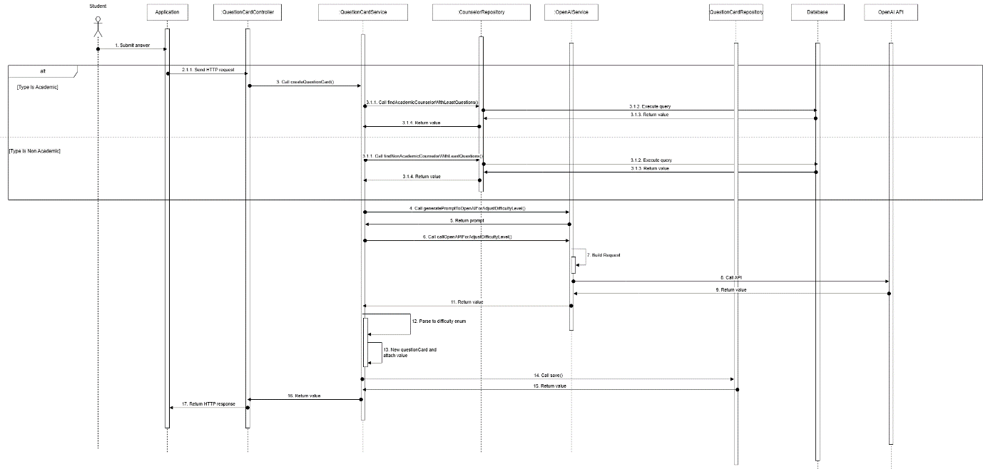

##### 3.2.2.2. Counselor answer question sequence diagram

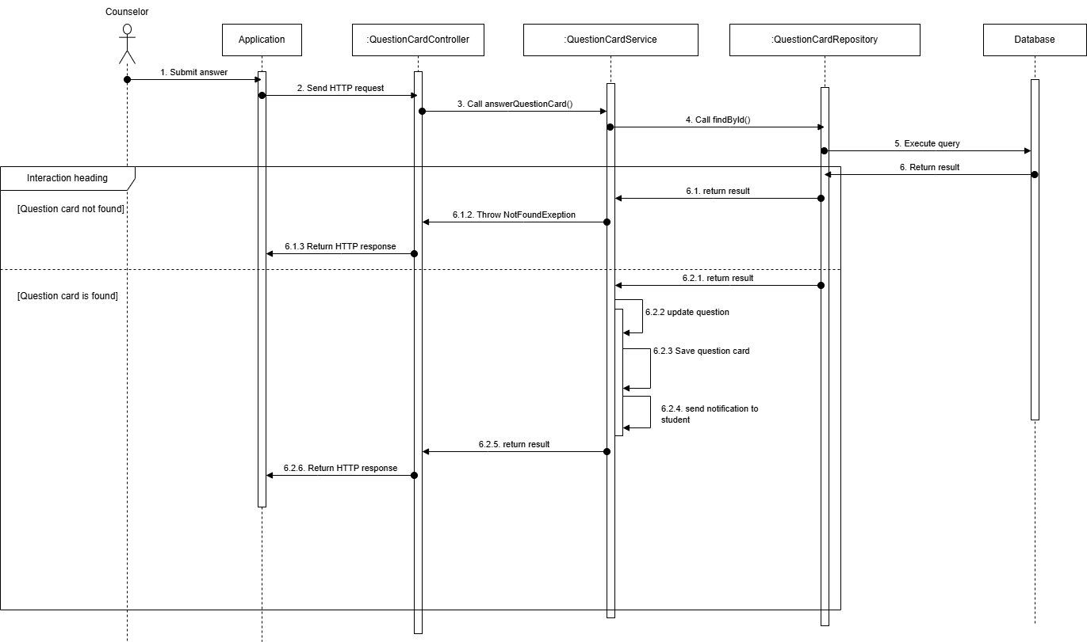

##### 3.2.2.3. Counselor closes question sequence diagram

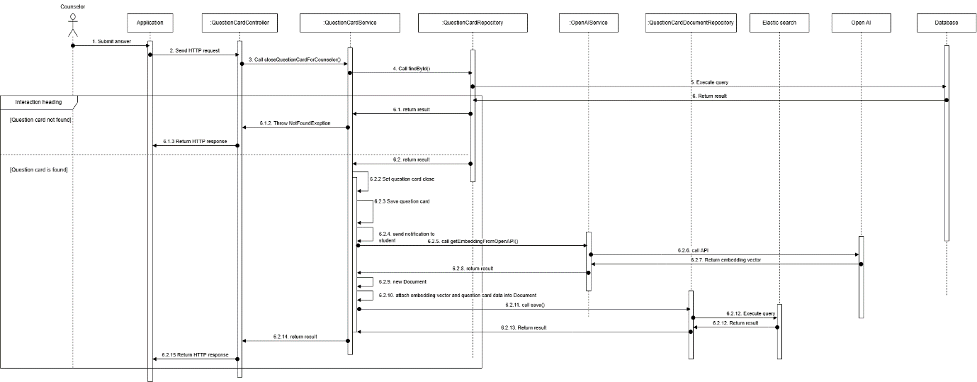

##### 3.2.2.4. Student accepts question sequence diagram

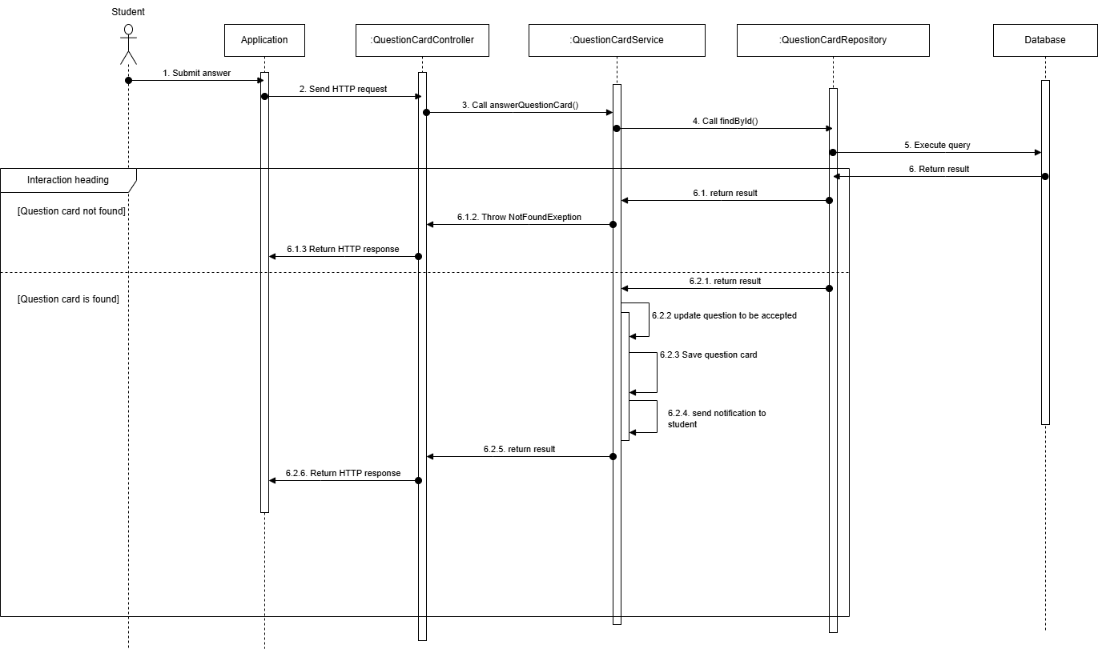

##### 3.2.2.5 Student initiate chat sequence diagram

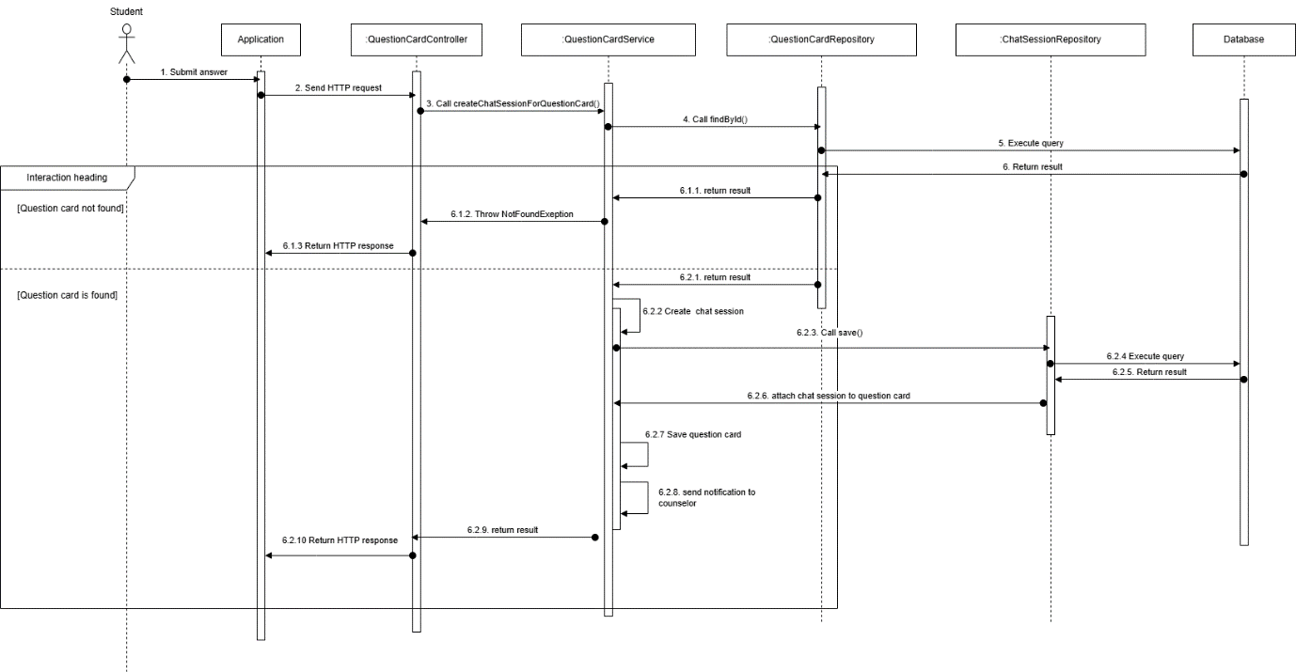

#### 3.2.3. Activity Diagram

##### 3.2.3.1. Create question activity diagram

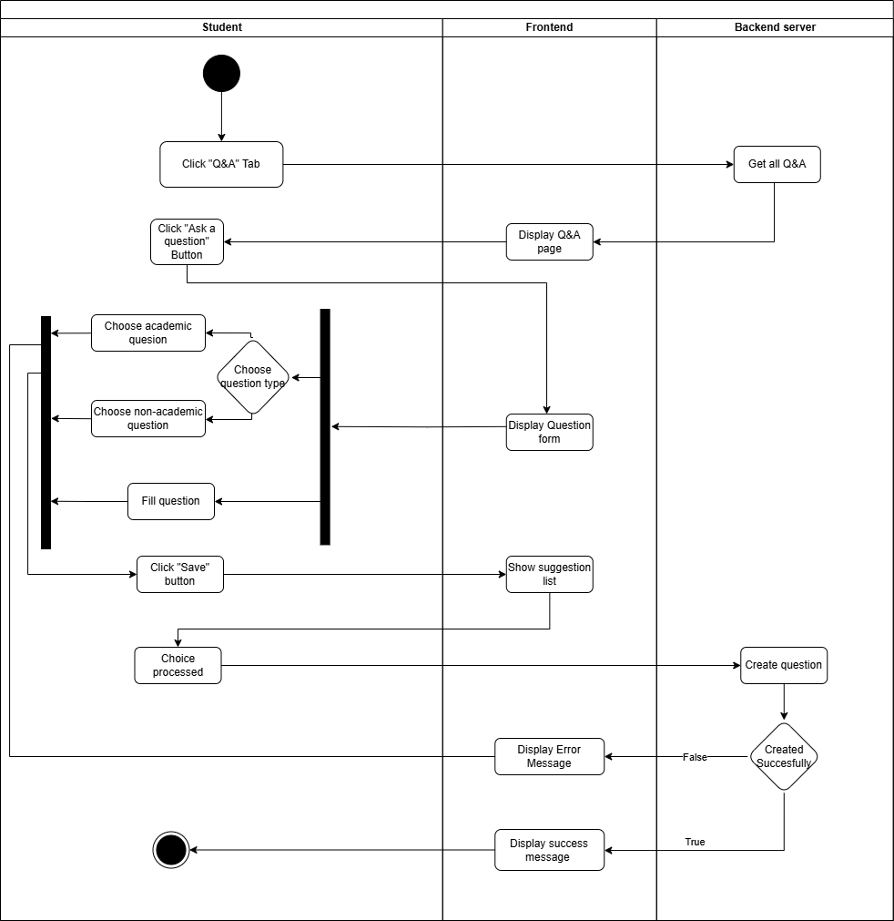

##### 3.2.3.2. Answer question activity diagram

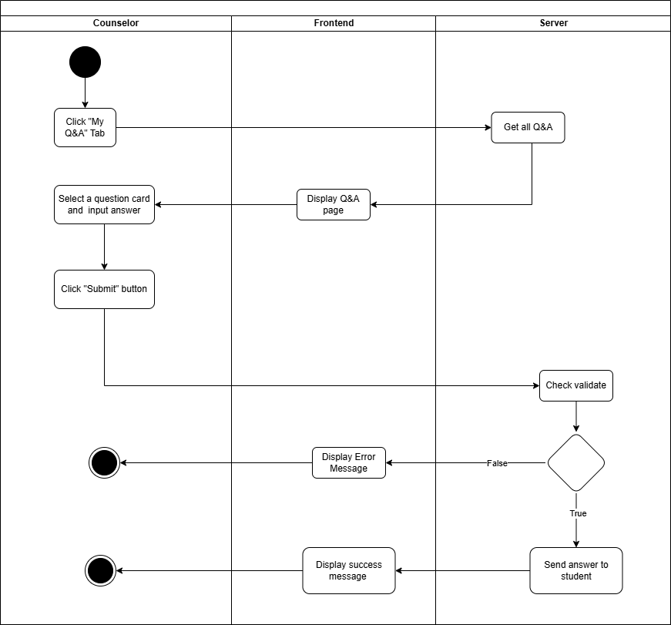

##### 3.2.3.3. Flag question activity diagram

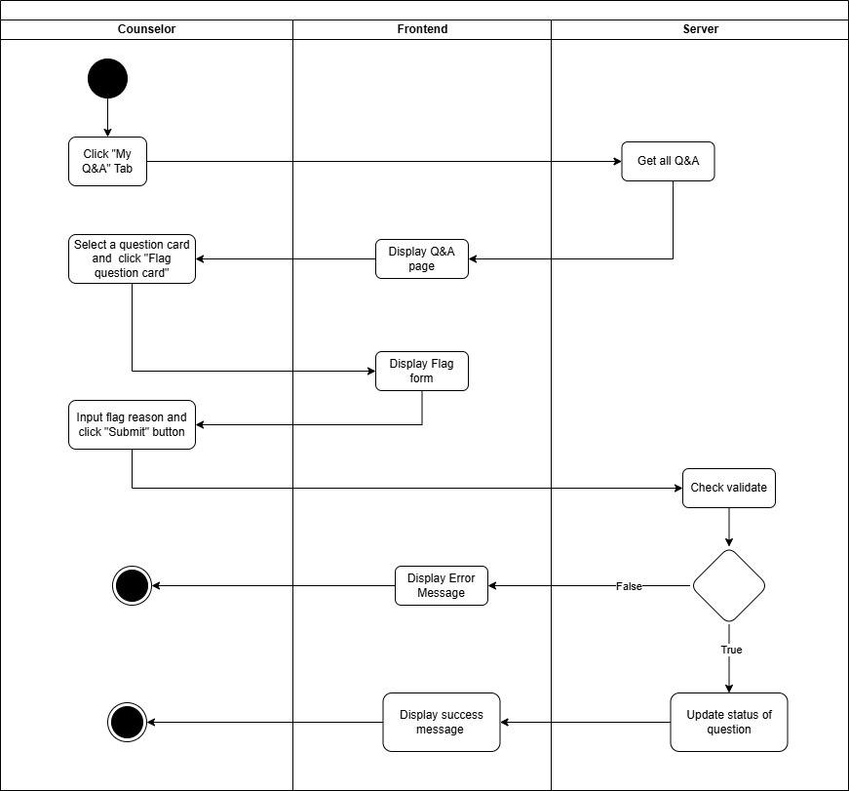

##### 3.2.3.4. Close question activity diagram

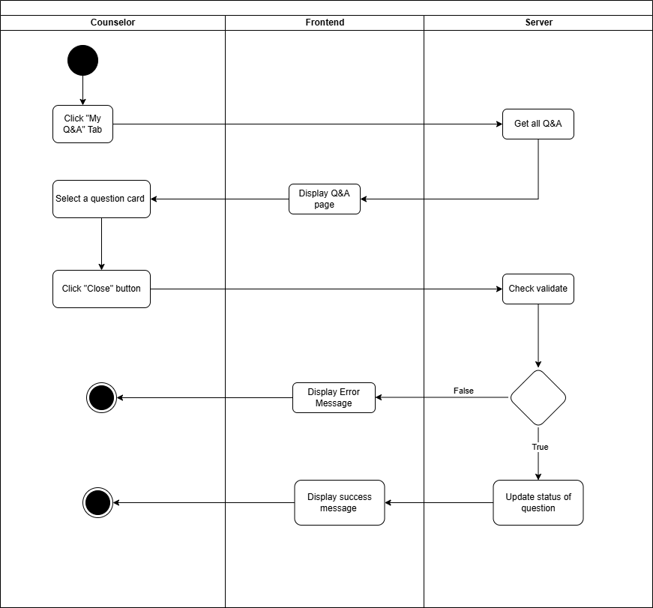

##### 3.2.3.5. Chat in session activity diagram

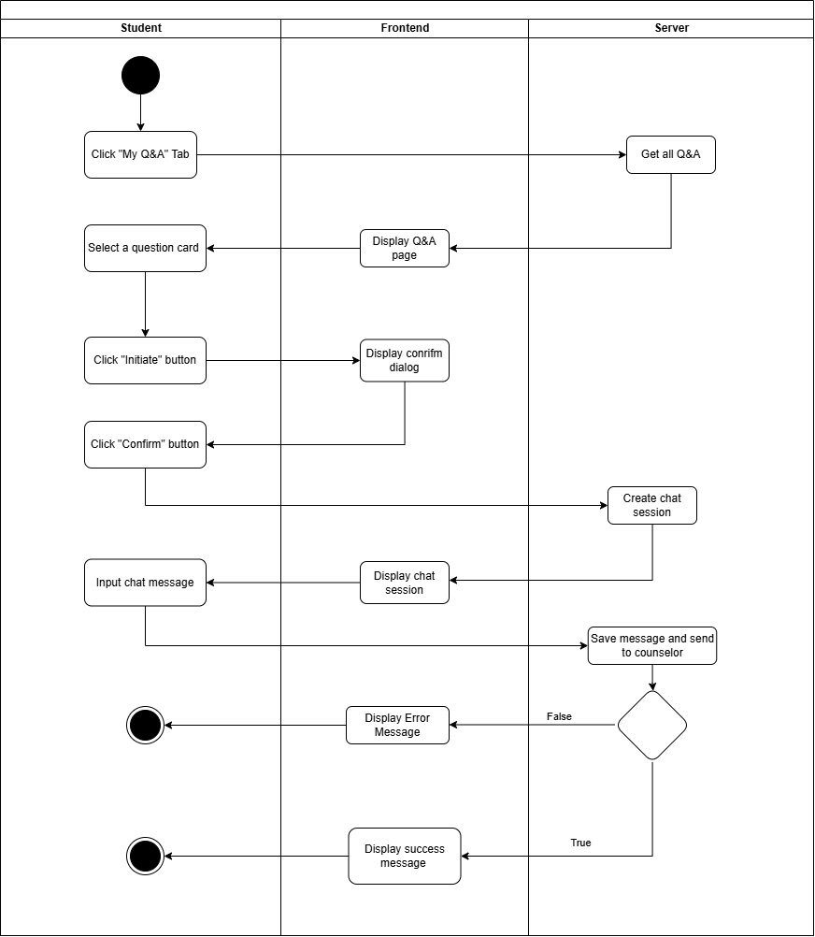

#### 3.2.4. State Machine Diagram

##### 3.2.4.1. Q&A State Machine Diagram

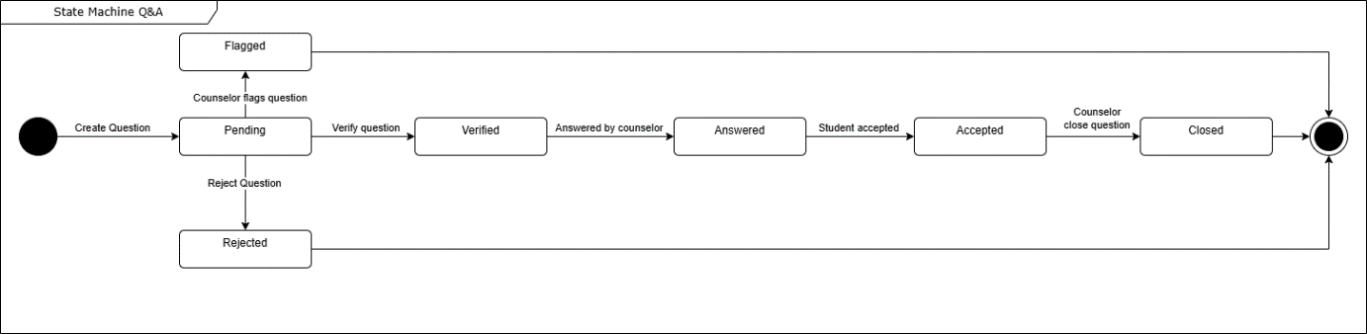

### 3.3. Staff-Driven Student Support and Counselor Matching for student’s demand

#### 3.3.1. Class Diagram

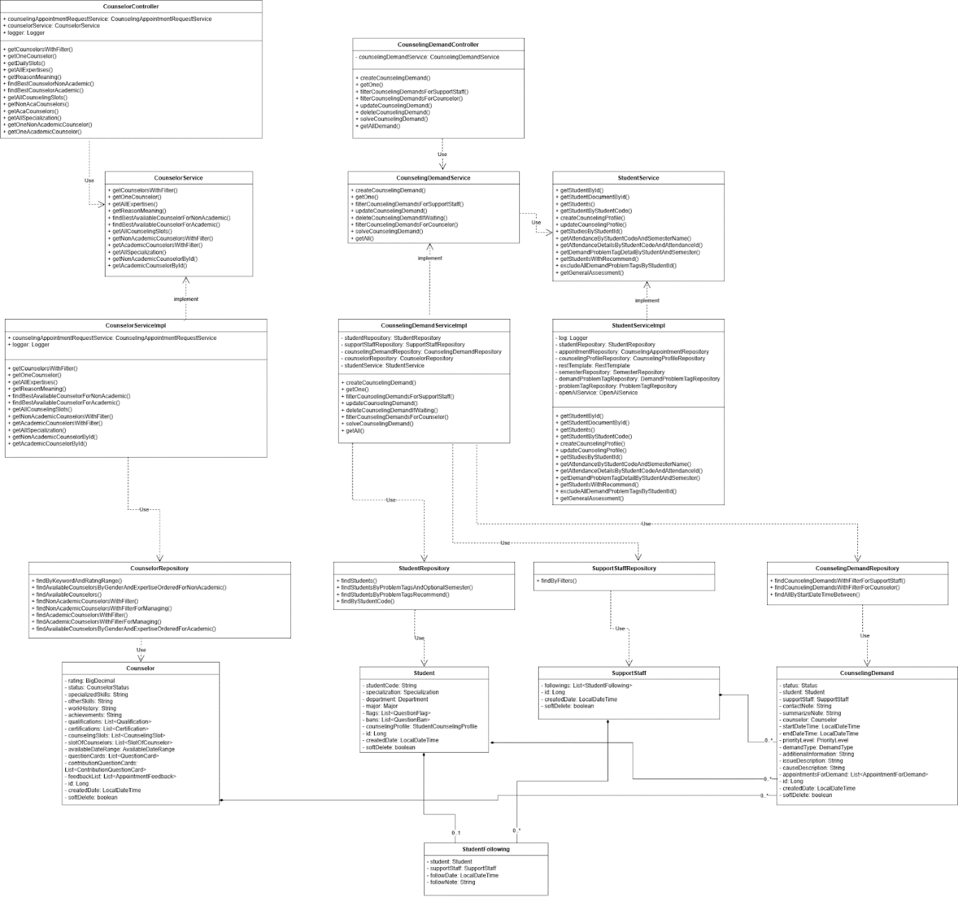

##### 3.3.1.1. Class Specification

###### 3.3.1.1.1. CounselorController class

|  |  |  |  |  |
| --- | --- | --- | --- | --- |
| **No** | **Attribute** | **Data Type** | **Visibility** | **Description** |
| 1 | counselingAppointmentRequestService | CounselingAppointmentRequestService | Public |  |
| 2 | counselorService | CounselorService | Public |  |
| 3 | logger | Logger | Public |  |

|  |  |  |  |
| --- | --- | --- | --- |
| **No** | **Method** | **Visibility** | **Description** |
| 1 | createAppointmentRequest() | Public |  |
| 2 | getAppointmentsRequest() | Public |  |
| 3 | getAppointmentsRequestOfStudentForManage() | Public |  |
| 4 | findAllAppointmentRequest() | Public |  |
| 5 | approveOnlineAppointment() | Public |  |
| 6 | approveOfflineAppointment() | Public |  |
| 7 | denyAppointmentRequest() | Public |  |
| 8 | getAppointmentsByDateRange() | Public |  |
| 9 | updateAppointmentDetails() | Public |  |
| 10 | submitFeedback() | Public |  |
| 11 | takeAttendance() | Public |  |
| 12 | cancelAppointmentForStudent() | Public |  |
| 13 | cancelAppointmentForCounselor() | Public |  |

###### 3.3.1.1.2. CounselorService class

|  |  |  |  |
| --- | --- | --- | --- |
| **No** | **Method** | **Visibility** | **Description** |
| 1 | getCounselorsWithFilter() | Public |  |
| 2 | getOneCounselor() | Public |  |
| 3 | getAllExpertises() | Public |  |
| 4 | getReasonMeaning() | Public |  |
| 5 | findBestAvailableCounselorForNonAcademic() | Public |  |
| 6 | findBestAvailableCounselorForAcademic() | Public |  |
| 7 | getAllCounselingSlots() | Public |  |
| 8 | getNonAcademicCounselorsWithFilter() | Public |  |
| 9 | getAcademicCounselorsWithFilter() | Public |  |
| 10 | getAllSpecialization() | Public |  |
| 11 | getNonAcademicCounselorById() | Public |  |
| 12 | getAcademicCounselorById() | Public |  |

###### 3.3.1.1.3. CounselorServiceImpl class

|  |  |  |  |  |
| --- | --- | --- | --- | --- |
| **No** | **Attribute** | **Data Type** | **Visibility** | **Description** |
| 1 | counselingAppointmentRequestService | CounselingAppointmentRequestService | Public |  |
| 2 | logger | Logger | Public |  |

|  |  |  |  |
| --- | --- | --- | --- |
| **No** | **Method** | **Visibility** | **Description** |
| 1 | getCounselorsWithFilter() | Public |  |
| 2 | getOneCounselor() | Public |  |
| 3 | getAllExpertises() | Public |  |
| 4 | getReasonMeaning() | Public |  |
| 5 | findBestAvailableCounselorForNonAcademic() | Public |  |
| 6 | findBestAvailableCounselorForAcademic() | Public |  |
| 7 | getAllCounselingSlots() | Public |  |
| 8 | getNonAcademicCounselorsWithFilter() | Public |  |
| 9 | getAcademicCounselorsWithFilter() | Public |  |
| 10 | getAllSpecialization() | Public |  |
| 11 | getAllSpecialization() | Public |  |
| 12 | getNonAcademicCounselorById() | Public |  |
| 13 | getAcademicCounselorById() | Public |  |

###### 3.3.1.1.4. CounselorRepository class

|  |  |  |  |
| --- | --- | --- | --- |
| **No** | **Method** | **Visibility** | **Description** |
| 1 | findByKeywordAndRatingRange() | Public |  |
| 2 | findAvailableCounselorsByGenderAndExpertiseOrderedForNonAcademic() | Public |  |
| 3 | findAvailableCounselors() | Public |  |
| 4 | findNonAcademicCounselorsWithFilter() | Public |  |
| 5 | findNonAcademicCounselorsWithFilterForManaging() | Public |  |
| 6 | findAcademicCounselorsWithFilter() | Public |  |
| 7 | findAcademicCounselorsWithFilterForManaging() | Public |  |
| 8 | findAvailableCounselorsByGenderAndExpertiseOrderedForAcademic() | Public |  |

###### 3.3.1.1.5. Counselor class

|  |  |  |  |  |
| --- | --- | --- | --- | --- |
| **No** | **Attribute** | **Data Type** | **Visibility** | **Description** |
| 1 | rating | BigDecimal | Private |  |
| 2 | status | CounselorStatus | Private |  |
| 3 | specializedSkills | String | Private |  |
| 4 | otherSkills | String | Private |  |
| 5 | workHistory | String | Private |  |
| 6 | achievements | String | Private |  |
| 7 | qualifications | List<Qualification> | Private |  |
| 8 | certifications | List<Certification> | Private |  |
| 9 | counselingSlots | List<CounselingSlot> | Private |  |
| 10 | slotOfCounselors | List<SlotOfCounselor> | Private |  |
| 11 | availableDateRange | AvailableDateRange | Private |  |
| 12 | questionCards | List<QuestionCard> | Private |  |
| 13 | contributionQuestionCards | List<ContributionQuestionCard> | Private |  |
| 14 | feedbackList | List<AppointmentFeedback> | Private |  |
| 15 | id | Long | Private |  |
| 16 | createdDate | LocalDateTime | Private |  |
| 17 | softDelete | boolean | Private |  |

###### 3.3.1.1.6. Student class

|  |  |  |  |  |
| --- | --- | --- | --- | --- |
| **No** | **Attribute** | **Data Type** | **Visibility** | **Description** |
| 1 | studentCode | String | Private |  |
| 2 | specialization | Specialization | Private |  |
| 3 | department | Department | Private |  |
| 4 | major | Major | Private |  |
| 5 | flags | List<QuestionFlag> | Private |  |
| 6 | bans | List<QuestionBan> | Private |  |
| 7 | counselingProfile | StudentCounselingProfile | Private |  |
| 8 | id | Long | Private |  |
| 9 | createdDate | LocalDateTime | Private |  |
| 10 | softDelete | boolean | Private |  |

###### 3.3.1.1.7. CounselingDemand class

|  |  |  |  |  |
| --- | --- | --- | --- | --- |
| **No** | **Attribute** | **Data Type** | **Visibility** | **Description** |
| 1 | status | Status | Private |  |
| 2 | student | Student | Private |  |
| 3 | supportStaff | SupportStaff | Private |  |
| 4 | contactNote | String | Private |  |
| 5 | summarizeNote | String | Private |  |
| 6 | counselor | Counselor | Private |  |
| 7 | startDateTime | LocalDateTime | Private |  |
| 8 | endDateTime | LocalDateTime | Private |  |
| 9 | priorityLevel | PriorityLevel | Private |  |
| 10 | demandType | DemandType | Private |  |
| 11 | additionalInformation | String | Private |  |
| 12 | issueDescription | String | Private |  |
| 13 | causeDescription | String | Private |  |
| 14 | appointmentsForDemand | List<AppointmentForDemand> | Private |  |
| 15 | id | Long | Private |  |
| 16 | createdDate | LocalDateTime | Private |  |
| 17 | softDelete | boolean | Private |  |

###### 3.3.1.1.8. StudentFollowing class

|  |  |  |  |  |
| --- | --- | --- | --- | --- |
| **No** | **Attribute** | **Data Type** | **Visibility** | **Description** |
| 1 | student | Student | Private |  |
| 2 | supportStaff | SupportStaff | Private |  |
| 3 | followDate | LocalDateTime | Private |  |
| 4 | followNote | String | Private |  |

###### 3.3.1.1.9. StudentRepository class

|  |  |  |  |
| --- | --- | --- | --- |
| **No** | **Method** | **Visibility** | **Description** |
| 1 | findStudents() | Public |  |
| 2 | findStudentsByProblemTagsAndOptionalSemester() | Public |  |
| 3 | findStudentsByProblemTagsRecommend() | Public |  |
| 4 | findByStudentCode() | Public |  |

###### 3.3.1.1.10. SupportStaffRepository class

|  |  |  |  |
| --- | --- | --- | --- |
| **No** | **Method** | **Visibility** | **Description** |
| 1 | findByFilters() | Public |  |

###### 3.3.1.1.11. CounselingDemandController class

|  |  |  |  |  |
| --- | --- | --- | --- | --- |
| **No** | **Attribute** | **Data Type** | **Visibility** | **Description** |
| 1 | counselingDemandService | CounselingDemandService | Private |  |

|  |  |  |  |
| --- | --- | --- | --- |
| **No** | **Method** | **Visibility** | **Description** |
| 1 | createCounselingDemand() | Public |  |
| 2 | getOne() | Public |  |
| 3 | filterCounselingDemandsForSupportStaff() | Public |  |
| 4 | filterCounselingDemandsForCounselor() | Public |  |
| 5 | updateCounselingDemand() | Public |  |
| 6 | deleteCounselingDemand() | Public |  |
| 7 | solveCounselingDemand() | Public |  |
| 8 | getAllDemand() | Public |  |

###### 3.3.1.1.12. CounselingDemandRepository class

|  |  |  |  |
| --- | --- | --- | --- |
| **No** | **Method** | **Visibility** | **Description** |
| 1 | findCounselingDemandsWithFilterForSupportStaff() | Public |  |
| 2 | findCounselingDemandsWithFilterForCounselor() | Public |  |
| 3 | findAllByStartDateTimeBetween() | Public |  |

###### 3.3.1.1.13. SupportStaff class

|  |  |  |  |  |
| --- | --- | --- | --- | --- |
| **No** | **Attribute** | **Data Type** | **Visibility** | **Description** |
| 1 | following: | List<StudentFollowing> | Private |  |
| 2 | id | SupportStaLongff | Private |  |
| 3 | createdDate | LocalDateTime | Private |  |
| 4 | softDelete | boolean | Private |  |

###### 3.3.1.1.14. CounselingDemandService class

|  |  |  |  |
| --- | --- | --- | --- |
| **No** | **Method** | **Visibility** | **Description** |
| 1 | createCounselingDemand() | Public |  |
| 2 | getOne() | Public |  |
| 3 | filterCounselingDemandsForSupportStaff() | Public |  |
| 4 | updateCounselingDemand() | Public |  |
| 5 | deleteCounselingDemandIfWaiting() | Public |  |
| 6 | filterCounselingDemandsForCounselor() | Public |  |
| 7 | solveCounselingDemand() | Public |  |
| 8 | getAll() | Public |  |

###### 3.3.1.1.15. CounselingDemandService class

|  |  |  |  |
| --- | --- | --- | --- |
| **No** | **Method** | **Visibility** | **Description** |
| 1 | getStudentById() | Public |  |
| 2 | getStudentDocumentById() | Public |  |
| 3 | getStudents() | Public |  |
| 4 | getStudentByStudentCode() | Public |  |
| 5 | createCounselingProfile() | Public |  |
| 6 | updateCounselingProfile() | Public |  |
| 7 | getStudiesByStudentId() | Public |  |
| 8 | getAttendanceByStudentCodeAndSemesterName() | Public |  |
| 9 | getAttendanceDetailsByStudentCodeAndAttendanceId() | Public |  |
| 10 | getDemandProblemTagDetailByStudentAndSemester() | Public |  |
| 11 | getStudentsWithRecommend() | Public |  |
| 12 | excludeAllDemandProblemTagsByStudentId() | Public |  |
| 13 | getGeneralAssessment() | Public |  |

###### 3.3.1.1.16. CounselingDemandServiceImpl class

|  |  |  |  |  |
| --- | --- | --- | --- | --- |
| **No** | **Attribute** | **Data Type** | **Visibility** | **Description** |
| 1 | studentRepository | CounselingAppointmentRequestService | Public |  |
| 2 | counselingDemandRepository | CounselingDemandRepository | Public |  |
| 3 | counselorRepository | CounselorRepository | Public |  |
| 4 | studentService: | StudentService |  |  |

|  |  |  |  |
| --- | --- | --- | --- |
| **No** | **Method** | **Visibility** | **Description** |
| 1 | createCounselingDemand() | Public |  |
| 2 | getOne() | Public |  |
| 3 | filterCounselingDemandsForSupportStaff() | Public |  |
| 4 | updateCounselingDemand() | Public |  |
| 5 | deleteCounselingDemandIfWaiting() | Public |  |
| 6 | filterCounselingDemandsForCounselor() | Public |  |
| 7 | solveCounselingDemand() | Public |  |
| 8 | getAll() | Public |  |

###### 3.3.1.1.17. CounselingDemandService class

|  |  |  |  |
| --- | --- | --- | --- |
| **No** | **Method** | **Visibility** | **Description** |
| 1 | getStudentById() | Public |  |
| 2 | getStudentDocumentById() | Public |  |
| 3 | getStudents() | Public |  |
| 4 | getStudentByStudentCode() | Public |  |
| 5 | createCounselingProfile() | Public |  |
| 6 | updateCounselingProfile() | Public |  |
| 7 | getStudiesByStudentId() | Public |  |
| 8 | getAttendanceByStudentCodeAndSemesterName() | Public |  |
| 9 | getAttendanceDetailsByStudentCodeAndAttendanceId() | Public |  |
| 10 | getDemandProblemTagDetailByStudentAndSemester() | Public |  |
| 11 | getStudentsWithRecommend() | Public |  |
| 12 | excludeAllDemandProblemTagsByStudentId() | Public |  |
| 13 | getGeneralAssessment() | Public |  |

###### 3.3.1.1.18. StudentServiceImpl class

|  |  |  |  |  |
| --- | --- | --- | --- | --- |
| **No** | **Attribute** | **Data Type** | **Visibility** | **Description** |
| 1 | log: Logger | CounselingAppointmentRequestService | Public |  |
| 2 | studentRepository | CounselingDemandRepository | Public |  |
| 3 | appointmentRepository | CounselingAppointmentRepository | Public |  |
| 4 | counselingProfileRepository | CounselingProfileRepository | Public |  |
| 5 | restTemplate | RestTemplate | Public |  |
| 6 | semesterRepository | SemesterRepository | Public |  |
| 7 | demandProblemTagRepositor | DemandProblemTagRepository | Public |  |
| 8 | openAIService | OpenAIService | Public |  |
| 9 | problemTagRepository | ProblemTagRepository | Public |  |

|  |  |  |  |
| --- | --- | --- | --- |
| **No** | **Method** | **Visibility** | **Description** |
| 1 | getStudentById() | Public |  |
| 2 | getStudentDocumentById() | Public |  |
| 3 | getStudents() | Public |  |
| 4 | getStudentByStudentCode() | Public |  |
| 5 | createCounselingProfile() | Public |  |
| 6 | updateCounselingProfile() | Public |  |
| 7 | getStudiesByStudentId() | Public |  |
| 8 | getAttendanceByStudentCodeAndSemesterName() | Public |  |
| 9 | getAttendanceDetailsByStudentCodeAndAttendanceId() | Public |  |
| 10 | getDemandProblemTagDetailByStudentAndSemester() | Public |  |
| 11 | + getStudentsWithRecommend() | Public |  |
| 12 | excludeAllDemandProblemTagsByStudentId() | Public |  |
| 13 | getGeneralAssessment() | Public |  |

#### 3.3.2. Sequence Diagram

##### 3.3.2.1. Support staff follows student sequence diagram

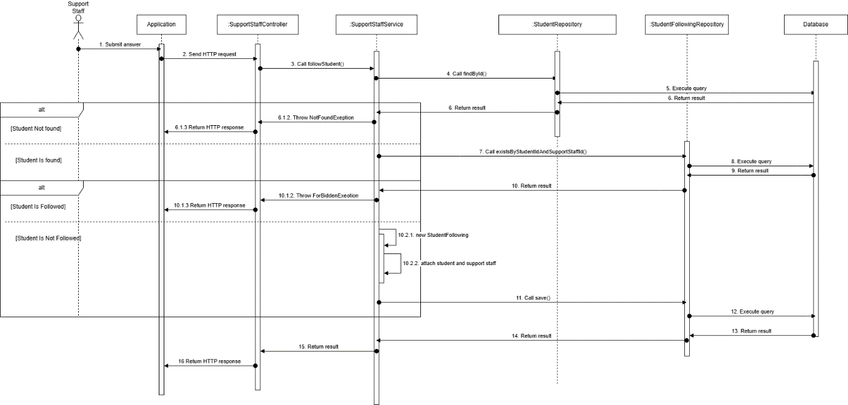

##### 3.3.2.2. Support staff create demand card sequence diagram

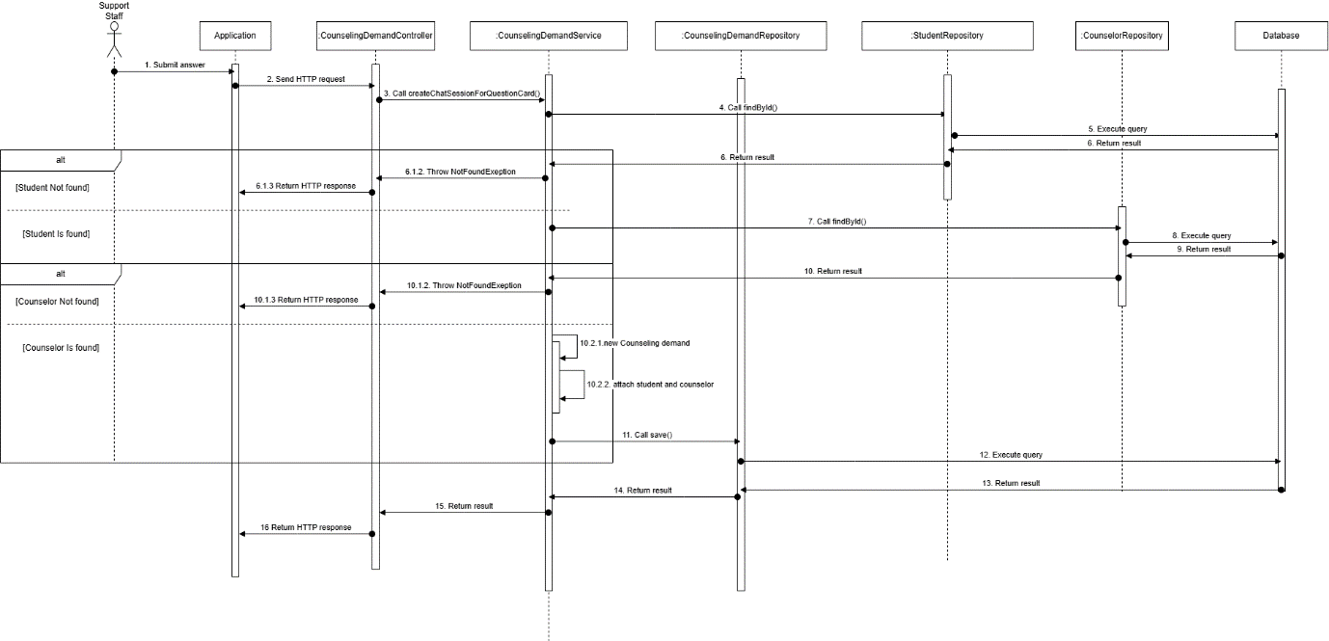

##### 3.3.2.3. Counselor creates appointment and attach to demand card sequence diagram

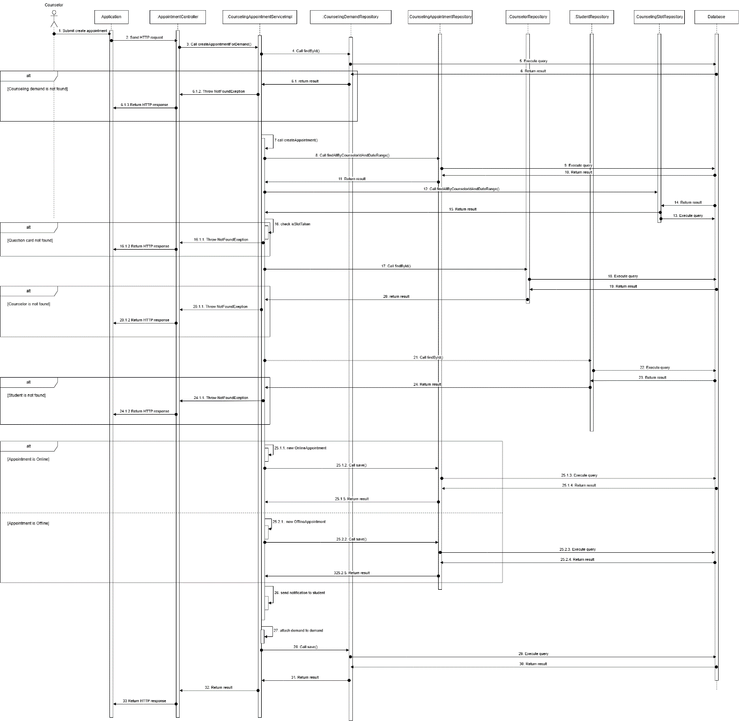

##### 3.3.2.4. Counselor solves demand card sequence diagram

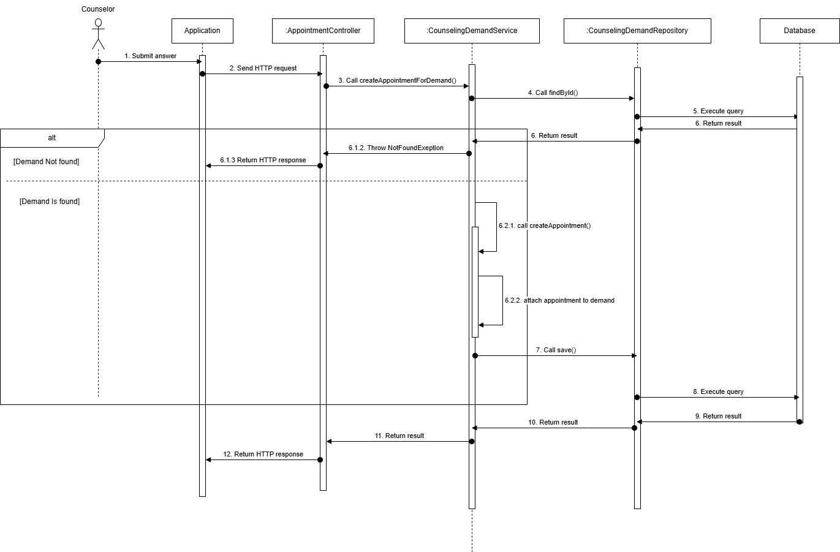

#### 3.3.3. Activity Diagram

##### 3.3.3.1. Staff Create demand card for mapping counselor with student activity diagram

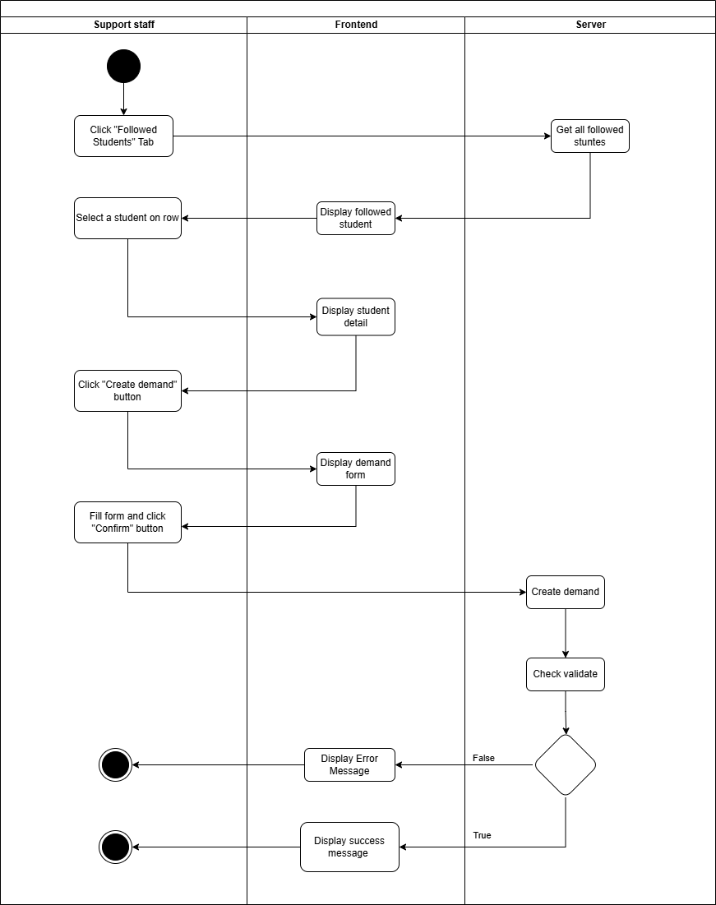

##### 3.3.3.1. Counselor Create appointment for demand if student need activity diagram

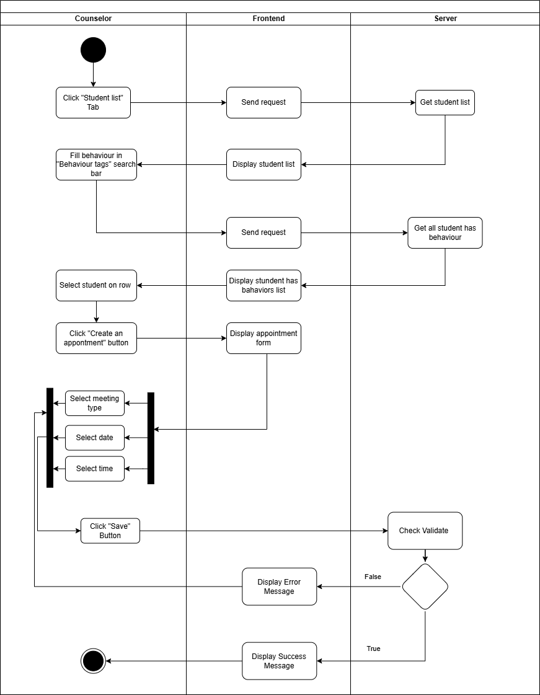

##### 3.3.3.2. Staff Follow student activity diagram

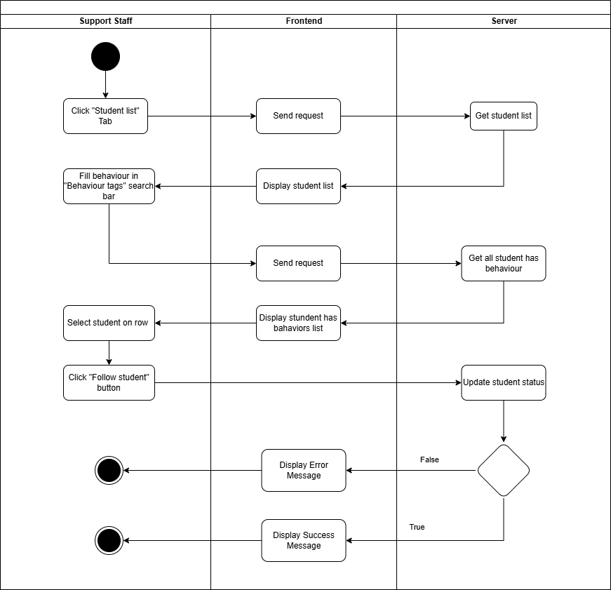

##### 3.3.3.3. Staff Unfollow student activity diagram

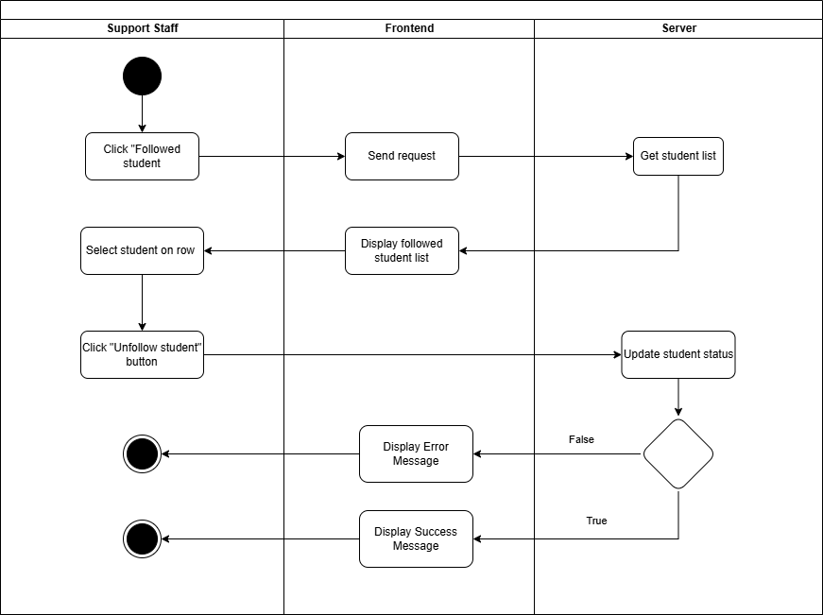

##### 3.3.3.4. Solve demand activity diagram

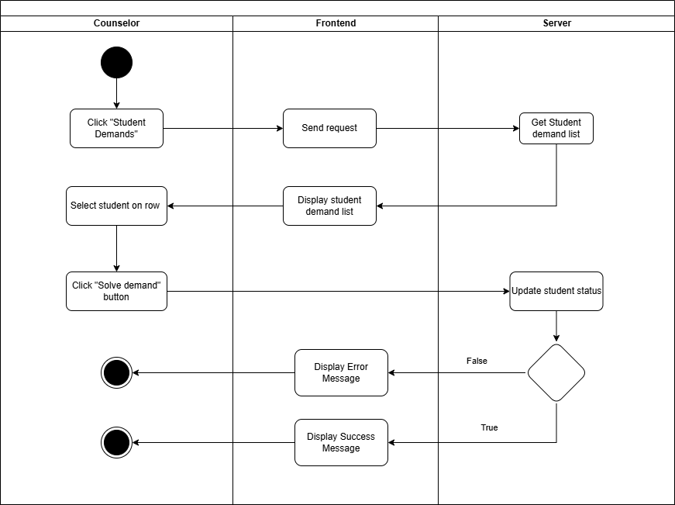

#### 3.3.4. State Machine Diagram

##### 3.3.4.1. Demand Mapping State Machine Diagram

